LINKS –

<https://www.programiz.com/python-programming/regex>

<https://docs.python.org/2/library/calendar.html#calendar.setfirstweekday>

<https://docs.python.org/2/library/datetime.html#module-datetime>

<https://docs.python.org/2/library/time.html#module-time>

ASOKAN ARTICLE

<https://www.quantamagazine.org/computer-scientist-donald-knuth-cant-stop-telling-stories-20200416/>

https://en.wikipedia.org/wiki/Stephen_C._Johnson

ASOKAN - LINUX

<https://builtin.com/software-engineering-perspectives/lean-agile-methodology-software-engineering>

<https://www.softwaretestinghelp.com/unix-text-processing-commands/>

<https://external-preview.redd.it/iigrixvxp5aYN9ox7Gr1dfI_rhLRotWlLsCafjJqjEQ.png?auto=webp&s=1594ddc17408cb9186a73c2a6d1a1bf1e00769dd> (List of commands)

<https://www.softwaretestinghelp.com/unix-text-processing-commands/>

<https://www.youtube.com/watch?v=Cn5fNea9jYo&feature=youtu.be>

<https://www.youtube.com/watch?v=BGjTboXjH28>

<https://www.youtube.com/watch?v=2FvltLP-IwE>

BOOKS -

Programming and Problem solving in python by kamthane

Corey Schafer - Python Programming Tutorials

PROGRAM NAMES –

LINUX –

PROGRAM 1 –

Write a bash script which does just one thing: saying "HELLO".

CODE –

echo "HELLO"

PROGRAM 2 –

Your task is to use for loops to display only odd natural numbers from 1 to 99

CODE

for number in {1..99..2}

do

    echo $number

done

PROGRAM 3 –

Write a Bash script which accepts name as input and displays a greeting: "Welcome (name)"

CODE –

printf "Welcome "

cat

printf writes "Hello " onto the standard output and cat copies everything from standard input to standard output after that. This works because Hackerrank closes the standard input (EOF) after writing to it. cat would copy everything including line breaks and not terminate otherwise. You can send EOF on any interactivelinux terminal by pressing Ctrl+D.

PROGRAM 4 –

Given two integers X,  and Y, find their sum, difference, product, and quotient.

CODE –

#!/bin/bash

read X

read Y

printf "%s\n" $X{+,-,*,/}"($Y)" | bc

PROGRAM 5 –

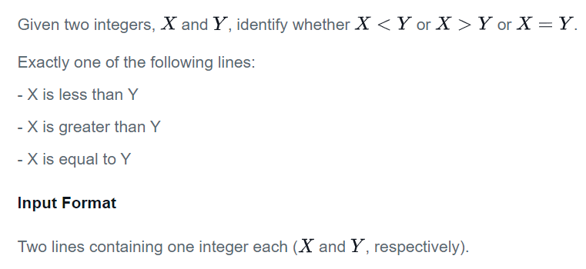

CODE –

#!/bin/bash

read x

read y

[[ $x -gt $y ]] && echo 'X is greater than Y'

[[ $x -eq $y ]] && echo 'X is equal to Y'

[[ $x -lt $y ]] && echo 'X is less than Y'

exit 0

#!/bin/bash

read X

read Y

if (( $X > $Y )); then

    printf "X is greater than Y"

elif (( $X == $Y )); then

    printf "X is equal to Y"

else

    printf "X is less than Y"

fi

PROGRAM 6 –

Read in one character from the user (this may be 'Y', 'y', 'N', 'n'). If the character is 'Y' or 'y' display "YES". If the character is 'N' or 'n' display "NO". No other character will be provided as input.

**Input Format**

One character (this may be 'Y', 'y', 'N', 'n').

**Constraints**

-

**Output Format**

One word: either "YES" or "NO" (quotation marks excluded).

CODE –

read char; echo -e "YES\nNO\n" | grep -i $char

PROGRAM 7 –

Given three integers (, , and ) representing the three sides of a triangle, identify whether the triangle is Scalene, Isosceles, or Equilateral.

**Input Format**

Three integers, each on a new line.

**Constraints**

Sum of any two sides will be greater than the third.

**Output Format**

One word: either "SCALENE" or "EQUILATERAL" or "ISOSCELES" (quotation marks excluded).

CODE –

#!/bin/bash

read a

read b

read c

if [ $a -eq $b ] || [ $a -eq $c ] || [ $c -eq $b ];then

    if [ $((a+b)) -eq $((c*2)) ];then

        echo "EQUILATERAL"

    else

        echo "ISOSCELES"

        fi

else

    echo "SCALENE"

    fi

PROGRAM 8 –

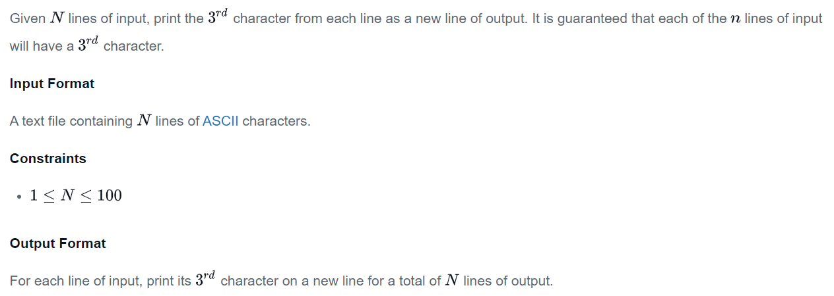

CODE

#!/bin/bash

while read line

do

echo $line | cut -c3 -

done

PROGRAM 9 –

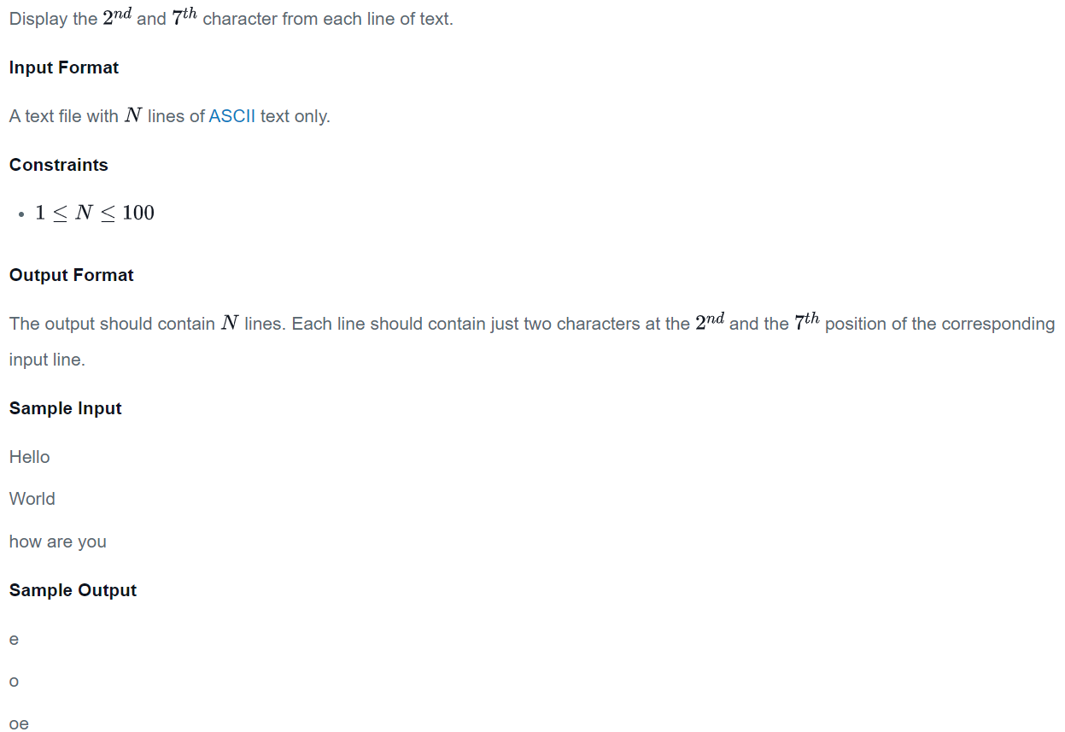

CODE

cut -c2,7 -

HERE – IS TO HANDLE THE CASES IN WHICH WORD HAS HYPHEN IN BETWEEN

PROGRAM 10 –

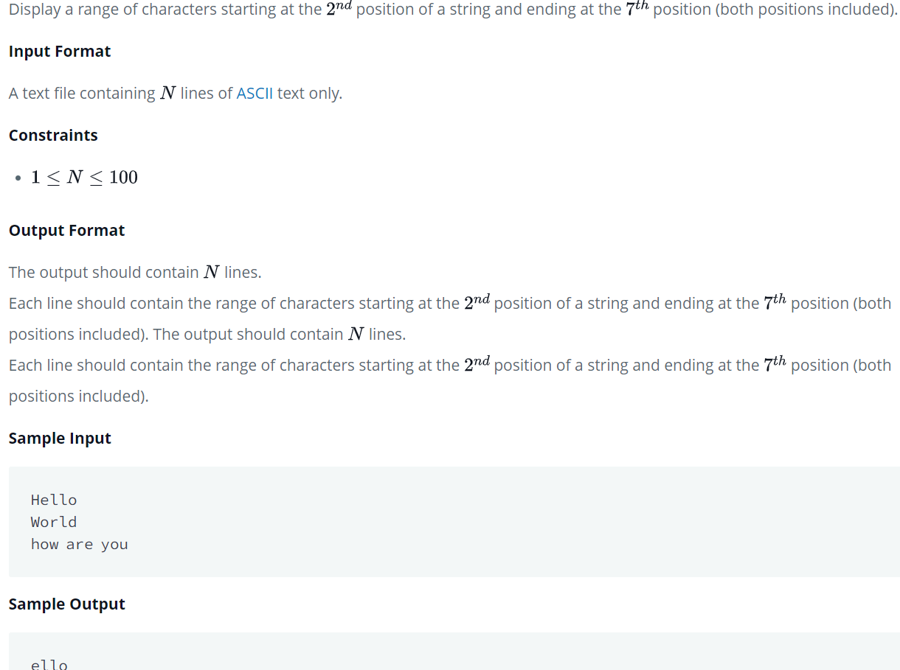

CODE –

cut -c2-7

PROGRAM 11 –

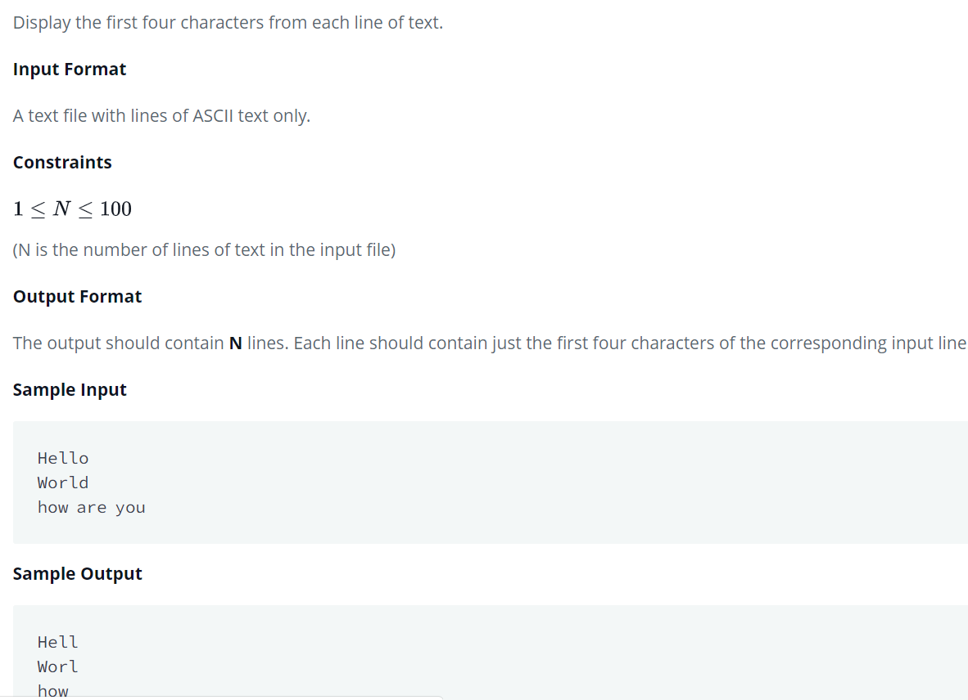

CODE –

cut -c-4

PROGRAM 12 –

Given a tab delimited file with several columns (tsv format) print the first three fields.

**Input Format**

A tab-separated file with lines of ASCII text only.

(N is the number of lines of text in the input file and C is the number of columns of data in the file)

**Output Format**

The output should contain N lines. For each line in the input, print the first three fields.

**Sample Input**

1 New York, New York[10] 8,244,910 1 New York-Northern New Jersey-Long Island, NY-NJ-PA MSA 19,015,900 1 New York-Newark-Bridgeport, NY-NJ-CT-PA CSA 22,214,083

2 Los Angeles, California 3,819,702 2 Los Angeles-Long Beach-Santa Ana, CA MSA 12,944,801 2 Los Angeles-Long Beach-Riverside, CA CSA 18,081,569

3 Chicago, Illinois 2,707,120 3 Chicago-Joliet-Naperville, IL-IN-WI MSA 9,504,753 3 Chicago-Naperville-Michigan City, IL-IN-WI CSA 9,729,825

4 Houston, Texas 2,145,146 4 Dallas-Fort Worth-Arlington, TX MSA 6,526,548 4 Washington-Baltimore-Northern Virginia, DC-MD-VA-WV CSA 8,718,083

5 Philadelphia, Pennsylvania[11] 1,536,471 5 Houston-Sugar Land-Baytown, TX MSA 6,086,538 5 Boston-Worcester-Manchester, MA-RI-NH CSA 7,601,061

**Sample Output**

1 New York, New York[10] 8,244,910

2 Los Angeles, California 3,819,702

3 Chicago, Illinois 2,707,120

4 Houston, Texas 2,145,146

5 Philadelphia, Pennsylvania[11] 1,536,471

cut -d $'\t' -f1-3 worked for me. -d only takes only one character so cut -d ' ' -f1-3 wouldn't work. also cut -d "\t" -f1-3 wouldn't work

cut -d $'\t' -f1-3

PROGRAM 13 –

Print the characters from thirteenth position to the end.

**Input Format**

A text file with lines of ASCII text only.

**Constraints**

(N is the number of lines of text in the input file)

**Output Format**

The output should contain N lines. For each input line, print the characters from thirteenth position to the end.

**Sample Input**

New York is a state in the Northeastern and Mid-Atlantic regions of the United States.

New York is the 27th-most extensive, the third-most populous populated of the 50 United States.

New York is bordered by New Jersey and Pennsylvania to the south.

About one third of all the battles of the Revolutionary War took place in New York.

Henry Hudson's 1609 voyage marked the beginning of European involvement with the area.

**Sample Output**

a state in the Northeastern and Mid-Atlantic regions of the United States.

the 27th-most extensive, the third-most populous populated of the 50 United States.

bordered by New Jersey and Pennsylvania to the south.

ird of all the battles of the Revolutionary War took place in New York.

's 1609 voyage marked the beginning of European involvement with the area.

cut -c13-

PROGRAM 14 –

Given a sentence, identify and display its fourth word. Assume that the space (' ') is the only delimiter between words.

**Input Format**

A text file with lines of ASCII text only. Each line has exactly one sentence.

**Constraints**

(N is the number of lines of text in the input file)

**Output Format**

The output should contain N lines.

For each input sentence, identify and display its fourth word. Assume that the space (' ') is the only delimiter between words.

**Sample Input**

Hello

World

how are you

**Sample Output**

Hello

World

cut -d " " -f4

PROGRAM 15 –

Given a sentence, identify and display its first three words. Assume that the space (' ') is the only delimiter between words.

**Input Format**

A text file with lines of ASCII text only. Each line has exactly one sentence.

**Constraints**

(N is the number of lines of text in the input file)

**Output Format**

The output should contain N lines. For each input sentence, identify and display its first three words. Assume that the space (' ') is the only delimiter between words.

**Sample Input**

New York is a state in the Northeastern and Mid-Atlantic regions of the United States.

New York is the 27th-most extensive, the third-most populous populated of the 50 United States.

New York is bordered by New Jersey and Pennsylvania to the south.

About one third of all the battles of the Revolutionary War took place in New York.

Henry Hudson's 1609 voyage marked the beginning of European involvement with the area.

**Sample Output**

New York is

New York is

New York is

About one third

Henry Hudson's 1609

cut -d ' ' -f1-3

PROGRAM 16 –

Given a tab delimited file with several columns (tsv format) print the fields from second fields to last field.

**Input Format**

A tab-separated file with lines of ASCII text only.

**Constraints**

(N is the number of lines of text in the input file and C is the number of columns of data in the file)

**Output Format**

The output should contain N lines.

For each line in the input, print the fields from second fields to last field.

**Sample Input**

1 New York, New York[10] 8,244,910 1 New York-Northern New Jersey-Long Island, NY-NJ-PA MSA 19,015,900 1 New York-Newark-Bridgeport, NY-NJ-CT-PA CSA 22,214,083

2 Los Angeles, California 3,819,702 2 Los Angeles-Long Beach-Santa Ana, CA MSA 12,944,801 2 Los Angeles-Long Beach-Riverside, CA CSA 18,081,569

3 Chicago, Illinois 2,707,120 3 Chicago-Joliet-Naperville, IL-IN-WI MSA 9,504,753 3 Chicago-Naperville-Michigan City, IL-IN-WI CSA 9,729,825

4 Houston, Texas 2,145,146 4 Dallas-Fort Worth-Arlington, TX MSA 6,526,548 4 Washington-Baltimore-Northern Virginia, DC-MD-VA-WV CSA 8,718,083

5 Philadelphia, Pennsylvania[11] 1,536,471 5 Houston-Sugar Land-Baytown, TX MSA 6,086,538 5 Boston-Worcester-Manchester, MA-RI-NH CSA 7,601,061

**Sample Output**

New York, New York[10] 8,244,910 1 New York-Northern New Jersey-Long Island, NY-NJ-PA MSA 19,015,900 1 New York-Newark-Bridgeport, NY-NJ-CT-PA CSA 22,214,083

Los Angeles, California 3,819,702 2 Los Angeles-Long Beach-Santa Ana, CA MSA 12,944,801 2 Los Angeles-Long Beach-Riverside, CA CSA 18,081,569

Chicago, Illinois 2,707,120 3 Chicago-Joliet-Naperville, IL-IN-WI MSA 9,504,753 3 Chicago-Naperville-Michigan City, IL-IN-WI CSA 9,729,825

Houston, Texas 2,145,146 4 Dallas-Fort Worth-Arlington, TX MSA 6,526,548 4 Washington-Baltimore-Northern Virginia, DC-MD-VA-WV CSA 8,718,083

Philadelphia, Pennsylvania[11] 1,536,471 5 Houston-Sugar Land-Baytown, TX MSA 6,086,538 5 Boston-Worcester-Manchester, MA-RI-NH CSA 7,601,061

cut -f 2-

Cut uses tab by default as delimiter

cut -f 2-

-f - option to specify which fields to keep

2- = specify the field number from which to keep so here 2- keeps from field number 2 to the end of the line.

PROGRAM 17 –

using the *head* command to display the first  lines of a text file.

Display the first 20 lines of an input file.

head -n 20 $1

PROGRAM 18 –

using the *head* command to display the first 20 characters of a text file.

Display the first  characters of an input file.

head -c20

PROGRAM 19 –

Display the lines (from line number 12 to 22, both inclusive) of a given text file

head -22 | tail -11

That is still happening here. Let's look at each component in turn.

head -22

This will grab the first 22 lines of the input.

Now let's pipe the output (the 22 lines) from the head command to the tail...

tail -11

You will get the 11 lines from the bottom of the head command. So you get lines 12-22. The head command gives you the upper limit while the tail command gives you the lower limit. I hope this helped!

PROGRAM 20 –

Display the last 20 lines of an input file.

tail -n 20

PROGRAM 21 –

Display the last 20 characters of an input file

tail -c 20

PROGRAM 22 –



tr "()" "[]"

PROGRAM 23 –

Delete all the lowercase characters in the given block of text

tr -d a-z

PROGRAM 24 –

Given a list of countries, each on a new line, your task is to read them into an array and then display the entire array, with a space between each of the countries' names.

#!bin/ksh

i=0

while read line

do

array[$i]=$line

((i+=1))

done

echo ${array[@]}

PROGRAM 25 –

Given a list of countries, each on a new line, your task is to read them into an array. Then slice the array and display only the elements lying between positions 3 and 7, both inclusive. Indexing starts from from 0.

arr=($(cat))

echo ${arr[@]:3:5}

PROGRAM 26 –

You are given a list of countries, each on a new line. Your task is to read them into an array and then filter out (remove) all the names containing the letter '*a*' or '*A*'.

**Input Format**

The input format consists of a list of country names, each on a separate line. The only characters present in the country names will be upper or lower case characters and hyphens.

**Output Format**

From the given list, remove the names that contain '*a*' or '*A*' in them. If there are no names left after removing these characters, you should display a blank line.

arr=($(cat))

echo ${arr[@]/*[aA]*/}

PROGRAM 27 –

Given a list of countries, each on a new line, your task is to read them into an array. Then, concatenate the array with itself (twice) - so that you have a total of three repetitions of the original array - and then display the entire concatenated array, with a space between each of the countries' names.

X=$(xargs)

echo $X $X $X

PROGRAM 28 –

HACKERRANK

QUESTION 1 –

Let's learn about list comprehensions! You are given three integers and representing the dimensions of a cuboid along with an integer . You have to print a list of all possible coordinates given by on a 3D grid where the sum of is not equal to . Here,

Input Format

Four integers and each on four separate lines, respectively.

Print the list in lexicographic increasing order.

Sample Input 0

1

1

1

2

Sample Output 0

[[0, 0, 0], [0, 0, 1], [0, 1, 0], [1, 0, 0], [1, 1, 1]]

Explanation 0

Concept

You have already used lists in previous hacks. List comprehensions are an elegant way to build a list without having to use different for loops to append values one by one. This example might help.

Example: You are given two integers x and y . You need to find out the ordered pairs ( i , j ) , such that ( i + j ) is not equal to n and print them in lexicographic order.( 0 <= i <= x ) and ( 0 <= j <= y) This is the code if we dont use list comprehensions in Python.

x = int ( raw_input())

y = int ( raw_input())

n = int ( raw_input())

ar = [] p = 0

for i in range ( x + 1 ) :

for j in range( y + 1):

if i+j != n:

ar.append([])

ar[p] = [ i , j ]

p+=1

print ar

Other smaller codes may also exist, but using list comprehensions is always a good option. Code using list comprehensions:

x = int ( raw_input())

y = int ( raw_input())

n = int ( raw_input())

print [ [ i, j] for i in range( x + 1) for j in range( y + 1) if ( ( i + j ) != n )]

Sample Input 1

2

2

2

2

Sample Output 1

[[0, 0, 0], [0, 0, 1], [0, 1, 0], [0, 1, 2], [0, 2, 1], [0, 2, 2], [1, 0, 0], [1, 0, 2], [1, 1, 1], [1, 1, 2], [1, 2, 0], [1, 2, 1], [1, 2, 2], [2, 0, 1], [2, 0, 2], [2, 1, 0], [2, 1, 1], [2, 1, 2], [2, 2, 0], [2, 2, 1], [2, 2, 2]]

CODE

x = int(input())

y = int(input())

z = int(input())

n = int(input())

print ([[i,j,k] for i in range(x+1) for j in range(y+1) for k in range(z+1) if i+j+k !=n])

QUESTION 2 –

You are given a date. Your task is to find what the day is on that date.

Input Format

A single line of input containing the space separated month, day and year, respectively, in format.

Output Format

Output the correct day in capital letters.

Sample Input

08 05 2015

Sample Output

WEDNESDAY

Explanation

The day on August 8th was WEDNESDAY.

CODE-

from calendar import *

n=list(input().split())

month=int(n[0])

day=int(n[1])

year=int(n[2])

week={6:"SUNDAY",0:"MONDAY",1:"TUESDAY",2:"WEDNESDAY",3:"THURSDAY",4:"FRIDAY",5:"SATURDAY"}

print(week[weekday(year,month,day)])

QUESTION 3-

Input Format

A single line containing a string .

Output Format

In the first line, print True if S has any alphanumeric characters. Otherwise, print False.

In the second line, print True if S has any alphabetical characters. Otherwise, print False.

In the third line, print True if S has any digits. Otherwise, print False.

In the fourth line, print True if S has any lowercase characters. Otherwise, print False.

In the fifth line, print True if S has any uppercase characters. Otherwise, print False.

CODE-

if _name_ == '_main_':

s = input()

for i in s:

if i.isalnum():

print("True")

break;

else:

print("False")

for i in s:

if i.isalpha():

print("True")

break;

else:

print("False")

for i in s:

if i.isdigit():

print("True")

break;

else:

print("False")

for i in s:

if i.islower():

print("True")

break;

else:

print("False")

for i in s:

if i.isupper():

print("True")

break;

else:

print("False")

QUESTION 4 –

You are given a string and width .

Your task is to wrap the string into a paragraph of width .

Input Format

The first line contains a string, .

The second line contains the width, .

Output Format

Print the text wrapped paragraph.

Sample Input 0

ABCDEFGHIJKLIMNOQRSTUVWXYZ

4

Sample Output 0

ABCD

EFGH

IJKL

IMNO

QRST

UVWX

YZ

CODE –

import textwrap

def wrap(string, max_width):

s=""

word_list = textwrap.TextWrapper(width=max_width).wrap(text=string)

return ('\n'.join(element for element in word_list))

if _name_ == '_main_':

string, max_width = input(), int(input())

result = wrap(string, max_width)

print(result)

QUESTION 5 –

Sample Input 0

Ross

Taylor

Sample Output 0

Hello Ross Taylor! You just delved into python.

CODE –

def print_full_name(a, b):

print("Hello", end=" ")

print(a, end=" ")

print(b, end="! ")

print("You just delved into python.")

if _name_ == '_main_':

first_name = input()

last_name = input()

print_full_name(first_name, last_name)

OR

def print_full_name(a, b):

s= "Hello "+a+" "+b+"! You just delved into python."

print(s)

QUESTION 6 –

Sample Input

this is a string

Sample Output

this-is-a-string

CODE-

def split_and_join(line):

line=line.split(" ")

line="-".join(line)

return line

if _name_ == '_main_':

line = input()

result = split_and_join(line)

print(result)

QUESTION 7 –

Input Format

The first line of input contains the original string. The next line contains the substring.

Each character in the string is an ascii character.

Output Format

Output the integer number indicating the total number of occurrences of the substring in the original string.

Sample Input

ABCDCDC

CDC

Sample Output

2

CODE

def count_substring(string, sub_string):

count=0

for i in range(len(string)-len(sub_string)+1):

if sub_string==string[i:i+len(sub_string)]:

count+=1

return count

if _name_ == '_main_':

string = input().strip()

sub_string = input().strip()

count = count_substring(string, sub_string)

print(count)

QUESTION 8 –

Consider a list (list = []). You can perform the following commands:

insert i e: Insert integer at position .

print: Print the list.

remove e: Delete the first occurrence of integer .

append e: Insert integer at the end of the list.

sort: Sort the list.

pop: Pop the last element from the list.

reverse: Reverse the list.

Initialize your list and read in the value of followed by lines of commands where each command will be of the types listed above. Iterate through each command in order and perform the corresponding operation on your list.

Input Format

The first line contains an integer, , denoting the number of commands.

Each line of the subsequent lines contains one of the commands described above.

The elements added to the list must be integers.

Output Format

For each command of type print, print the list on a new line.

Sample Input 0

12

insert 0 5

insert 1 10

insert 0 6

print

remove 6

append 9

append 1

sort

print

pop

reverse

print

Sample Output 0

[6, 5, 10]

[1, 5, 9, 10]

[9, 5, 1]

CODE-

if _name_ == '_main_':

l=[]

N = int(input())

for _ in range(N):

s=input()

s=s.split()

if s[0]=="insert":

l.insert(int(s[1]),int(s[2]))

elif s[0]=="print":

print(l)

elif s[0]=="remove":

l.remove(int(s[1]))

elif s[0]=="append":

l.append(int(s[1]))

elif s[0]=="sort":

l.sort()

elif s[0]=="pop":

l.pop()

elif s[0]=="reverse":

l.reverse()

QUESTION 9 –

Given the names and grades for each student in a Physics class of students, store them in a nested list and print the name(s) of any student(s) having the second lowest grade.

Note: If there are multiple students with the same grade, order their names alphabetically and print each name on a new line.

Input Format

The first line contains an integer, , the number of students.

The subsequent lines describe each student over lines; the first line contains a student's name, and the second line contains their grade.

There will always be one or more students having the second lowest grade.

Output Format

Print the name(s) of any student(s) having the second lowest grade in Physics; if there are multiple students, order their names alphabetically and print each one on a new line.

Sample Input 0

5

Harry

37.21

Berry

37.21

Tina

37.2

Akriti

41

Harsh

39

Sample Output 0

Berry

Harry

Explanation 0

There are students in this class whose names and grades are assembled to build the following list:

python students = [['Harry', 37.21], ['Berry', 37.21], ['Tina', 37.2], ['Akriti', 41], ['Harsh', 39]]

The lowest grade of belongs to Tina. The second lowest grade of belongs to both Harry and Berry, so we order their names alphabetically and print each name on a new line.

CODE-

student=[]

marks=[]

for z in range(int(input())):

student.append(input())

marks.append(float(input()))

final_report=[]

final_report.append(student)

final_report.append(marks)

i=min(final_report[1])

while min(final_report[1])==i:

k=final_report[1].index(i)

final_report[1].pop(k)

final_report[0].pop(k)

final_report[1].append(10000)

i=min(final_report[1])

winners=[]

while min(final_report[1])==i:

k=final_report[1].index(i)

final_report[1].pop(k)

winners.append(final_report[0][k])

final_report[0].pop(k)

winners.sort()

for i in winners:

print(i)

QUESTION 10 –

Input Format

The first line contains the integer , the number of students. The next lines contains the name and marks obtained by that student separated by a space. The final line contains the name of a particular student previously listed.

Output Format

Print one line: The average of the marks obtained by the particular student correct to 2 decimal places.

Sample Input 0

3

Krishna 67 68 69

Arjun 70 98 63

Malika 52 56 60

Malika

Sample Output 0

56.00

CODE-

n=int(input())

students=[]

marks=[]

for _ in range(n):

a=input()

a=a.split()

students.append(a[0])

a=list(float(a[n]) for n in range(1,len(a)))

marks.append(a)

x=input()

y=students.index(x)

z=sum(marks[y])

z=z/3

print("%.2f"%z)

QUESTION 11 –

Second largest number in array -

CODE-

n=int(input())

A=input()

A=A.split()

A=[int(i) for i in A ]

i=max(A)

while(max(A)==i):

A.remove(max(A))

print("{}".format(max(A)))

QUESTION 11 –

Input - nimisha doshi

Output - Nimisha Doshi

CODE-

def solve(s):

a_string = s.split(' ')

return(' '.join((word.capitalize() for word in a_string)))

if _name_ == '_main_':

fptr = open(os.environ['OUTPUT_PATH'], 'w')

s = input()

result = solve(s)

fptr.write(result + '\n')

fptr.close()

QUESTION 12 –

A *deque* is a double-ended queue. It can be used to add or remove elements from both ends.

Deques support thread safe, memory efficient appends and pops from either side of the deque with approximately the same  performance in either direction.

Click on the link to learn more about [**deque() methods**](https://docs.python.org/2/library/collections.html#deque-objects).  
Click on the link to learn more about various approaches to working with deques: [**Deque Recipes**](https://docs.python.org/2.7/library/collections.html#deque-recipes).

**Example**

**Code**

>>> from collections import deque

>>> d = deque()

>>> d.append(1)

>>> print d

deque([1])

>>> d.appendleft(2)

>>> print d

deque([2, 1])

>>> d.clear()

>>> print d

deque([])

>>> d.extend('1')

>>> print d

deque(['1'])

>>> d.extendleft('234')

>>> print d

deque(['4', '3', '2', '1'])

>>> d.count('1')

1

>>> d.pop()

'1'

>>> print d

deque(['4', '3', '2'])

>>> d.popleft()

'4'

>>> print d

deque(['3', '2'])

>>> d.extend('7896')

>>> print d

deque(['3', '2', '7', '8', '9', '6'])

>>> d.remove('2')

>>> print d

deque(['3', '7', '8', '9', '6'])

>>> d.reverse()

>>> print d

deque(['6', '9', '8', '7', '3'])

>>> d.rotate(3)

>>> print d

deque(['8', '7', '3', '6', '9'])

**Task**

Perform *append*, *pop*, *popleft* and *appendleft* methods on an empty deque .

**Input Format**

The first line contains an integer , the number of operations.  
The next  lines contains the space separated names of methods and their values.

**Constraints**

**Output Format**

Print the space separated elements of deque .

**Sample Input**

6

append 1

append 2

append 3

appendleft 4

pop

popleft

**Sample Output**

1 2

CODE –

from collections import deque

d=deque()

n=int(input())

for i in range(n):

n=input().split()

if n[0]=="append":

d.append(int(n[1]))

elif n[0]=="appendleft":

d.appendleft(int(n[1]))

elif n[0]=="pop":

d.pop()

else:

d.popleft()

for i in list(d):

print(i,end=" ")

QUESTION 13 –

The *defaultdict* tool is a container in the collections class of Python. It's similar to the usual dictionary (*dict*) container, but the only difference is that a defaultdict will have a *default* value if that key has not been set yet. If you didn't use a defaultdict you'd have to check to see if that key exists, and if it doesn't, set it to what you want.  
**For example:**

from collections import defaultdict

d = defaultdict(list)

d['python'].append("awesome")

d['something-else'].append("not relevant")

d['python'].append("language")

for i in d.items():

print i

This prints:

('python', ['awesome', 'language'])

('something-else', ['not relevant'])

In this challenge, you will be given  integers,  and . There are  words, which might repeat, in word group . There are  words belonging to word group . For each  words, check whether the word has appeared in group  or not. Print the indices of each occurrence of  in group . If it does not appear, print .

**Constraints**

**Input Format**

The first line contains integers,  and  separated by a space.  
The next  lines contains the words belonging to group .  
The next  lines contains the words belonging to group .

**Output Format**

Output  lines.  
The  line should contain the -indexed positions of the occurrences of the  word separated by spaces.

**Sample Input**

5 2

a

a

b

a

b

a

b

**Sample Output**

1 2 4

3 5

**Explanation**

**'a'** appeared  3 times in positions 1,2  and 4.  
**'b'** appeared 2 times in positions 3 and 5.  
In the sample problem, if **'c'** also appeared in word group , you would print .

CODE –

from collections import defaultdict

d=defaultdict(list)

n=list(map(int,input().split()))

for i in range(n[0]):

    d[(input())].append(i+1)

for i in range(n[1]):

    x=input()

    if len(d[x])==0:

        print(-1,end=" ")

    else:

        for j in d[x]:

            print(j,end=" ")

    print("")

QUESTION 14 –

An *OrderedDict* is a dictionary that remembers the order of the keys that were inserted first. If a new entry overwrites an existing entry, the original insertion position is left unchanged.

**Example**

**Code**

>>> from collections import OrderedDict

>>>

>>> ordinary_dictionary = {}

>>> ordinary_dictionary['a'] = 1

>>> ordinary_dictionary['b'] = 2

>>> ordinary_dictionary['c'] = 3

>>> ordinary_dictionary['d'] = 4

>>> ordinary_dictionary['e'] = 5

>>>

>>> print ordinary_dictionary

{'a': 1, 'c': 3, 'b': 2, 'e': 5, 'd': 4}

>>>

>>> ordered_dictionary = OrderedDict()

>>> ordered_dictionary['a'] = 1

>>> ordered_dictionary['b'] = 2

>>> ordered_dictionary['c'] = 3

>>> ordered_dictionary['d'] = 4

>>> ordered_dictionary['e'] = 5

>>>

>>> print ordered_dictionary

OrderedDict([('a', 1), ('b', 2), ('c', 3), ('d', 4), ('e', 5)])

**Task**

You are the manager of a supermarket.  
You have a list of  items together with their prices that consumers bought on a particular day.  
Your task is to print each item_name and net_price in order of its first occurrence.

item_name= Name of the item.  
net_price= Quantity of the item sold multiplied by the price of each item.

**Input Format**

The first line contains the number of items, .  
The next  lines contains the item's name and price, separated by a space.

**Constraints**

**Output Format**

Print the item_name and net_price in order of its first occurrence.

**Sample Input**

9

BANANA FRIES 12

POTATO CHIPS 30

APPLE JUICE 10

CANDY 5

APPLE JUICE 10

CANDY 5

CANDY 5

CANDY 5

POTATO CHIPS 30

**Sample Output**

BANANA FRIES 12

POTATO CHIPS 60

APPLE JUICE 20

CANDY 20

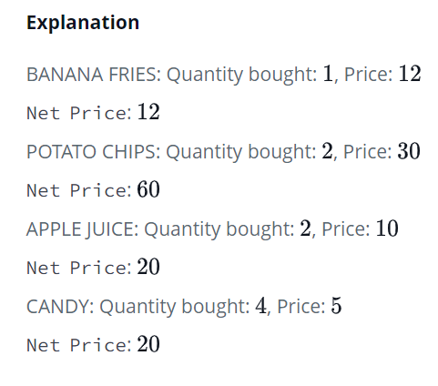

CODE –

from collections import OrderedDict

d=OrderedDict()

n=int(input())

for i in range(n):

    s=input().split()

    x=s[0:-1]

    x=" ".join(x)

    y=s[-1]

    y=int(y)

    d.setdefault(x,0)

    d[x]+=y

for x,y in d.items():

    print(x,y)

QUESTION 15 –

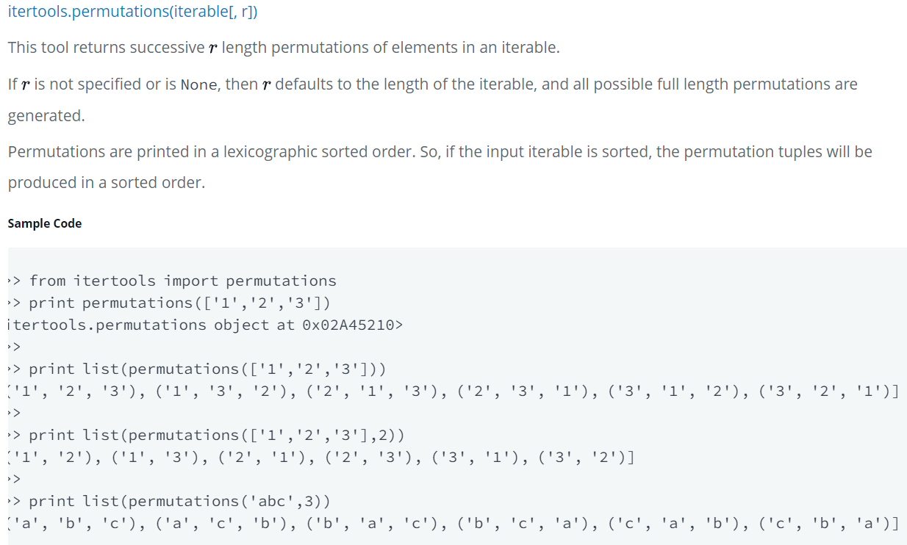

**Task**

You are given a string .  
Your task is to print all possible permutations of size  of the string in lexicographic sorted order.

**Input Format**

A single line containing the space separated string  and the integer value .

**Constraints**

The string contains only *UPPERCASE* characters.

**Output Format**

Print the permutations of the string  on separate lines.

**Sample Input**

HACK 2

**Sample Output**

AC

AH

AK

CA

CH

CK

HA

HC

HK

KA

KC

KH

**Explanation**

All possible size 2 permutations of the string "**HACK**" are printed in lexicographic sorted order.

CODE –

from itertools import permutations

n=input().split()

n[1]=int(n[1])

n[0]=list(n[0])

n[0].sort()

for i in list(permutations(n[0],n[1])):

    print("".join(i))

QUESTION 16 –

This tool returns the R length subsequences of elements from the input iterable.

Combinations are emitted in lexicographic sorted order. So, if the input iterable is sorted, the combination tuples will be produced in sorted order.

Sample code –

>>> from itertools import combinations

>>>

>>> print list(combinations('12345',2))

[('1', '2'), ('1', '3'), ('1', '4'), ('1', '5'), ('2', '3'), ('2', '4'), ('2', '5'), ('3', '4'), ('3', '5'), ('4', '5')]

>>>

>>> A = [1,1,3,3,3]

>>> print list(combinations(A,4))

[(1, 1, 3, 3), (1, 1, 3, 3), (1, 1, 3, 3), (1, 3, 3, 3), (1, 3, 3, 3)]

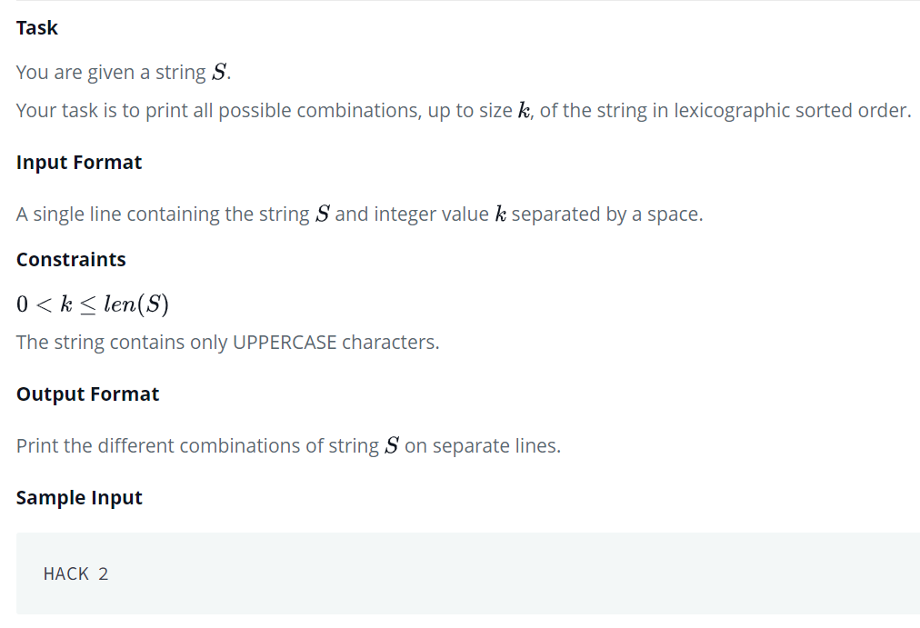

**Sample Output**

A

C

H

K

AC

AH

AK

CH

CK

HK

CODE –

from itertools import combinations

n=input().split()

n[0]=list(n[0])

n[0].sort()

n[1]=int(n[1])

final=[]

for i in range(1,n[1]+1):

    final.extend(list(combinations(n[0],i)))

for i in final:

    print("".join(i))

QUESTION 17 –

This tool returns R length subsequences of elements from the input iterable allowing individual elements to be *repeated more than once*.

Combinations are emitted in lexicographic sorted order. So, if the input iterable is sorted, the combination tuples will be produced in sorted order.

**Sample Code**

>>> from itertools import combinations_with_replacement

>>>

>>> print list(combinations_with_replacement('12345',2))

[('1', '1'), ('1', '2'), ('1', '3'), ('1', '4'), ('1', '5'), ('2', '2'), ('2', '3'), ('2', '4'), ('2', '5'), ('3', '3'), ('3', '4'), ('3', '5'), ('4', '4'), ('4', '5'), ('5', '5')]

>>>

>>> A = [1,1,3,3,3]

>>> print list(combinations(A,2))

[(1, 1), (1, 3), (1, 3), (1, 3), (1, 3), (1, 3), (1, 3), (3, 3), (3, 3), (3, 3)]

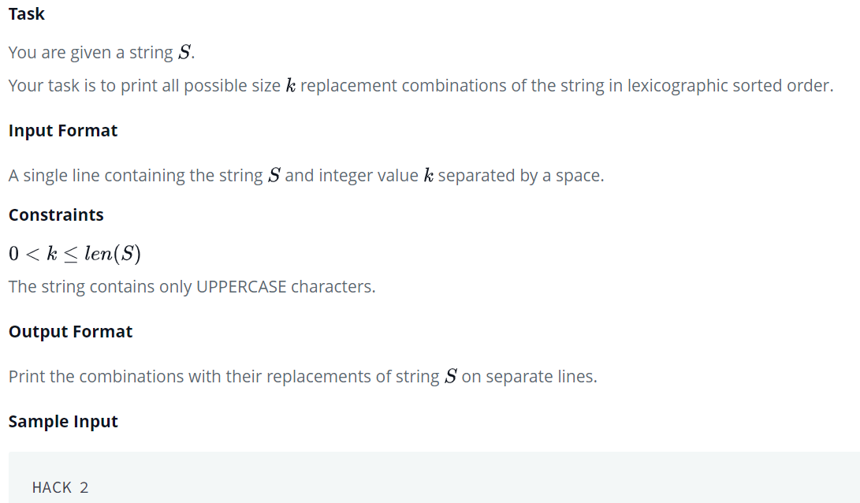**Sample Output**

AA

AC

AH

AK

CC

CH

CK

HH

HK

KK

CODE –

from itertools import combinations_with_replacement

n=input().split()

n[0]=list(n[0])

n[0].sort()

n[1]=int(n[1])

final=list(combinations_with_replacement(n[0],n[1]))

for i in final:

    print("".join(i))

QUESTION 18 –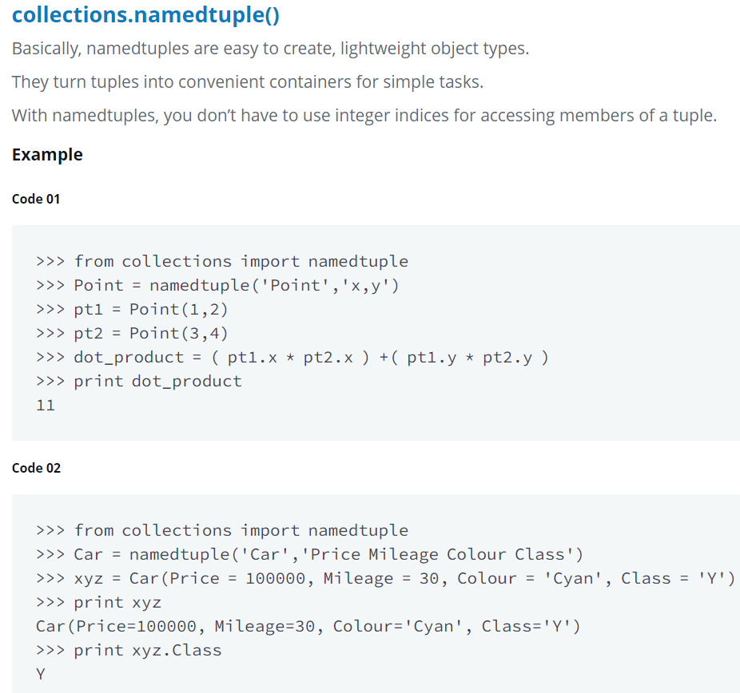

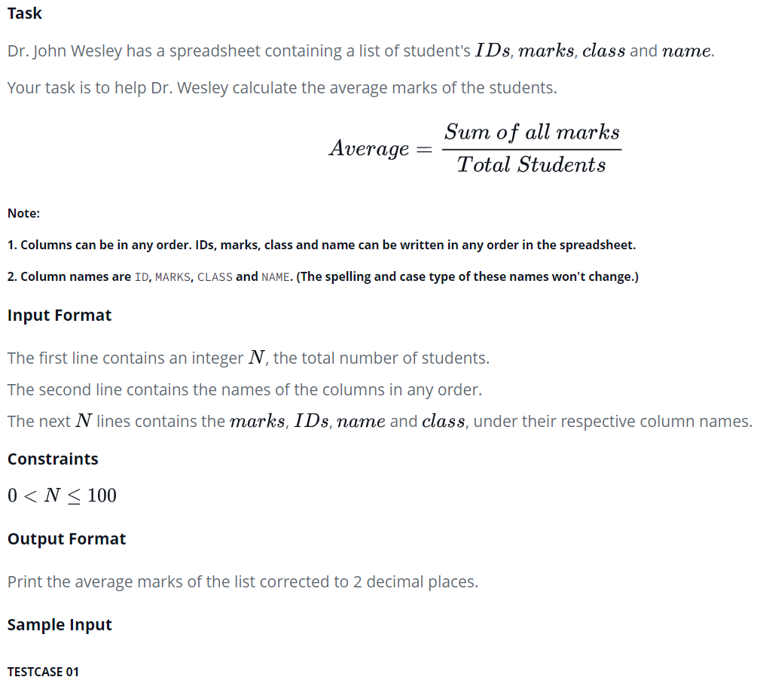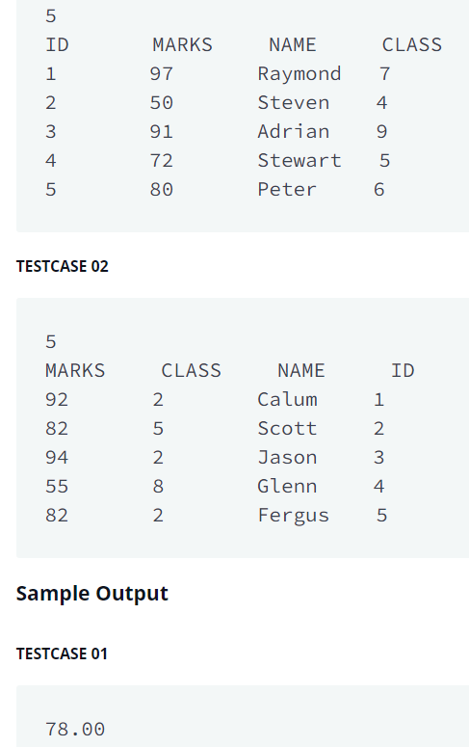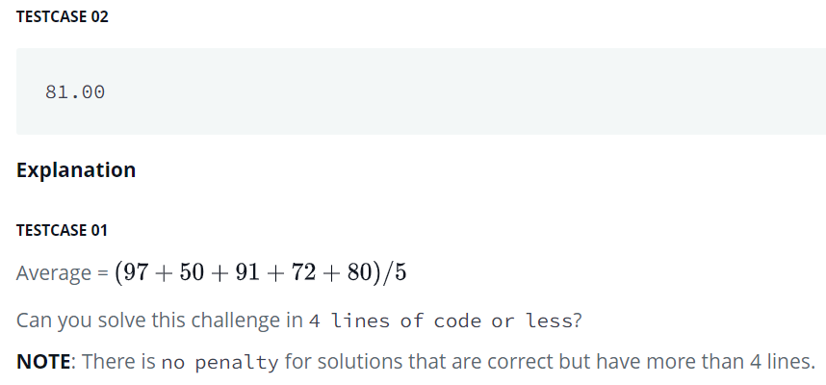

from collections import namedtuple

n=int(input())

profile=namedtuple("profile",input().split())

marks=[ int(profile._make(input().split()).MARKS)

for i in range(n)]

A=sum(marks)/len(marks)

print(A)

QUESTION 19 –

You are given a string, and you have to validate whether it's a valid Roman numeral. If it is valid, print True. Otherwise, print False. Try to create a regular expression for a valid Roman numeral.

**Input Format**

A single line of input containing a string of Roman characters.

**Output Format**

Output a single line containing True or False according to the instructions above.

**Constraints**

The number will be between 1 and 3999 (both included).

**Sample Input**

CDXXI

**Sample Output**

True

**References**

Regular expressions are a key concept in any programming language. A quick explanation with Python examples is [available here](http://www.thelearningpoint.net/computer-science/learning-python-programming-and-data-structures/learning-python-programming-and-data-structures--tutorial-13--regular-expression-matching). You could also go through the link below to read more about regular expressions in Python.

<https://developers.google.com/edu/python/regular-expressions>

regex_pattern = r"^(?!.*?([IVXCM])\1{3}|LL|DD)[IVXCMLD]+$"

import re

print(str(bool(re.match(regex_pattern, input()))))

QUESTION 20 –

These expressions return the indices of the *start* and *end* of the substring matched by the group.

**Code**

>>> import re

>>> m = re.search(r'\d+','1234')

>>> m.end()

4

>>> m.start()

0

**Task**  
You are given a string .  
Your task is to find the indices of the *start* and *end* of string  in .

**Input Format**

The first line contains the string .  
The second line contains the string .

**Constraints**

**Output Format**

Print the tuple in this format: (*start* _*index*, *end* _*index*).  
If no match is found, print (-1, -1).

**Sample Input**

aaadaa

aa

**Sample Output**

(0, 1)

(1, 2)

(4, 5)

import re

s = input()

k = input()

index = 0

if re.search(k, s):

    while index+len(k) <= len(s):

        m = re.search(k, s[index:]) #begins search with new index

        if(m):

            print("({0}, {1})".format(index+m.start(), index+m.end()-1))

            index += m.start() + 1

        else:

            index=len(s)+1;

         #assign new index by +1

else:

    print((-1, -1))

PROGRAM 21 –

A *set* is an unordered collection of elements without duplicate entries.  
When printed, iterated or converted into a sequence, its elements will appear in an arbitrary order.

**Example**

>>> print set()

set([])

>>> print set('HackerRank')

set(['a', 'c', 'e', 'H', 'k', 'n', 'r', 'R'])

>>> print set([1,2,1,2,3,4,5,6,0,9,12,22,3])

set([0, 1, 2, 3, 4, 5, 6, 9, 12, 22])

>>> print set((1,2,3,4,5,5))

set([1, 2, 3, 4, 5])

>>> print set(set(['H','a','c','k','e','r','r','a','n','k']))

set(['a', 'c', 'r', 'e', 'H', 'k', 'n'])

>>> print set({'Hacker' : 'DOSHI', 'Rank' : 616 })

set(['Hacker', 'Rank'])

>>> print set(enumerate(['H','a','c','k','e','r','r','a','n','k']))

set([(6, 'r'), (7, 'a'), (3, 'k'), (4, 'e'), (5, 'r'), (9, 'k'), (2, 'c'), (0, 'H'), (1, 'a'), (8, 'n')])

Basically, sets are used for membership testing and eliminating duplicate entries.  
  
**Task**

Now, let's use our knowledge of sets and help Mickey.

Ms. Gabriel Williams is a botany professor at District College. One day, she asked her student Mickey to compute the average of all the plants with distinct heights in her greenhouse.

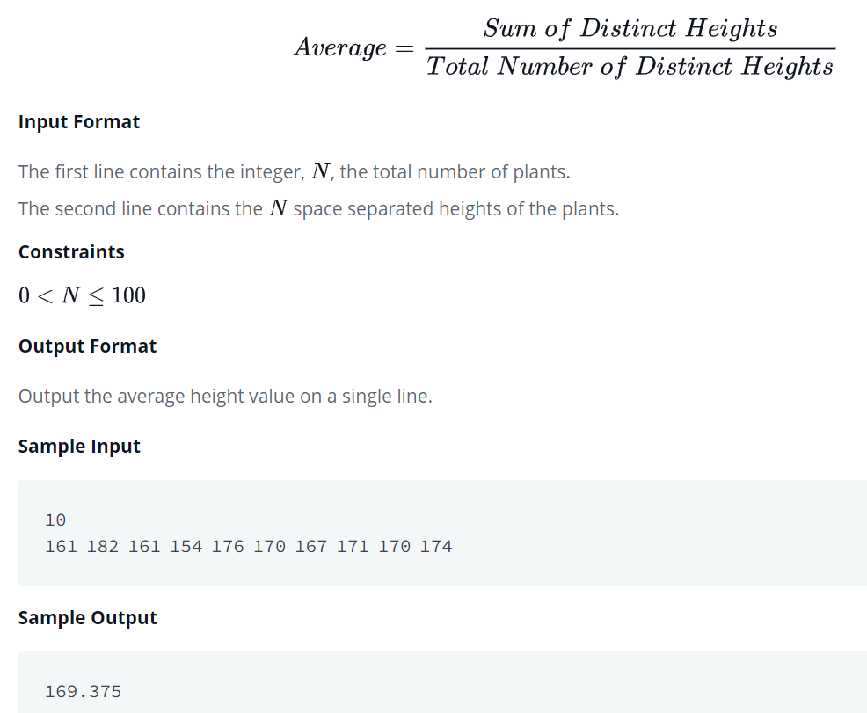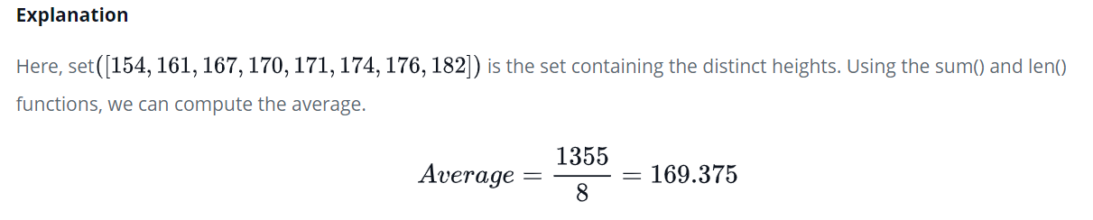

def average(array):

    a=set(array)

    b=sum(a)/len(a)

    return b

if __name__ == '__main__':

    n = int(input())

    arr = list(map(int, input().split()))

    result = average(arr)

    print(result)

PROGRAM 22 –

If we want to add a single element to an existing set, we can use the *.add()* operation.  
It adds the element to the set and returns 'None'.

**Example**

>>> s = set('HackerRank')

>>> s.add('H')

>>> print s

set(['a', 'c', 'e', 'H', 'k', 'n', 'r', 'R'])

>>> print s.add('HackerRank')

None

>>> print s

set(['a', 'c', 'e', 'HackerRank', 'H', 'k', 'n', 'r', 'R'])

**Task**

Apply your knowledge of the *.add()* operation to help your friend Rupal.  
  
Rupal has a huge collection of country stamps. She decided to count the total number of distinct country stamps in her collection. She asked for your help. You pick the stamps one by one from a stack of  country stamps.  
  
Find the total number of distinct country stamps.

**Input Format**

The first line contains an integer , the total number of country stamps.  
The next  lines contains the name of the country where the stamp is from.

**Constraints**

**Output Format**

Output the total number of distinct country stamps on a single line.

**Sample Input**

7

UK

China

USA

France

New Zealand

UK

France

**Sample Output**

5

**Explanation**

UK and France repeat twice. Hence, the total number of distinct country stamps is  (five).

n=int(input())

a=set()

for i in range(n):

    a.add(input())

print(len(a))

SOLOLEARN –

QUESTION 1 –

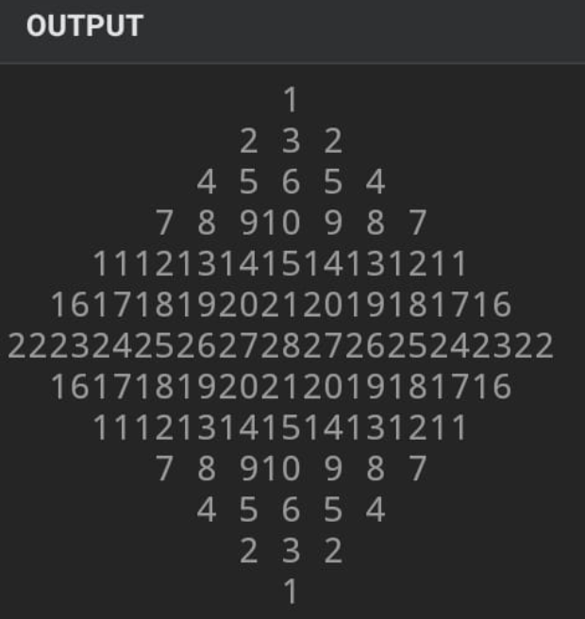

n=int(input() or "4")

w=len(str(n*(n+1)//2))

[print(' '*w*abs(r),

[str(x).rjust(w) for x in range((n-abs(r))(n-abs(r)-1)//2+1, (n-abs(r))*(n-abs(r)+1)//2)],

[str(x).rjust(w) for x in range((n-abs(r))(n-abs(r)+1)//2, (n-abs(r))*(n-abs(r)-1)//2, -1)],

sep='') for r in range(-n+1, n)]

QUESTION 2 –

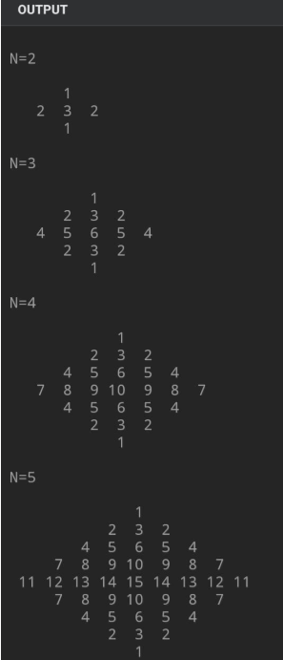

def pattern (n, M=lambda a: a+a[-2::-1]):

g, b = iter(range(1,n*n)), []

for k in range(1,n+1):

b += [[f'{next(g):>2}' for _ in range(k)]]

for row in M([*map(M, b)]):

print(f'{" ".join(row):^{n*5+int(n/2)+2}}')

for n in range(2,13): print(f'\nN={n}\n') or pattern(n)

QUESTION 3 –

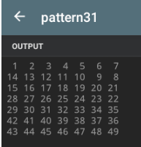

inp = int(input() or 7)

[print(*[f'{i:>2}' for i in range(j,j+inp)][::k]) for j,k in zip(range(1,inp*inp,inp),[1,-1]*inp)]

QUESTION 4 –

PANDIGIT NUMBER

from itertools import permutations as p

pdn = p('1023456789') #pandigital numbers

cnt = 1 # count from 1

while cnt <= 30:

x = next(pdn) # next pandigital number

if x[-1] in '13579': # if pdn is odd

print(f"{cnt:>2}: {''.join(x)}") #print it

cnt += 1 # increment count

TALENT SPRINT CODES –

QUESTION 1

CROSSWORD PUZZLE –

INPUT –

U r given the grid with white and black boxes. U have to determine the logic for black and white box, and also for the numbers displayed on the grid.

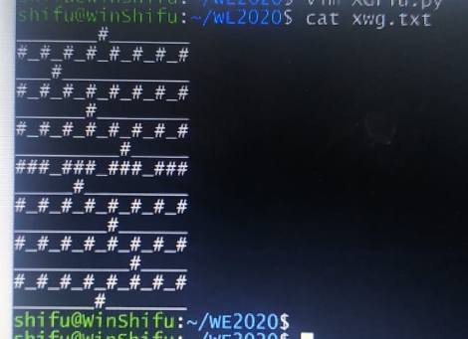

OUTPUT-

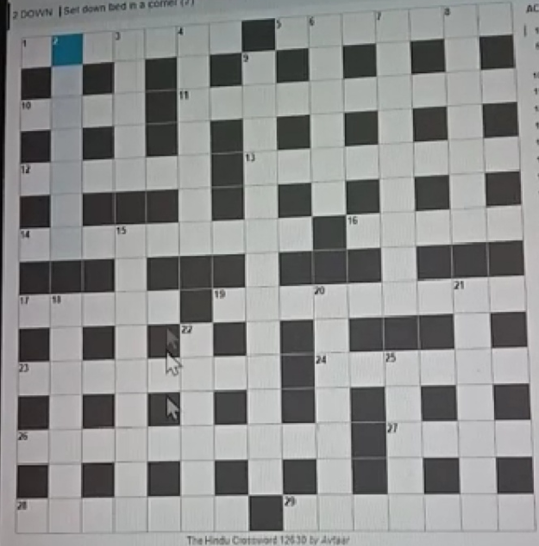

CODE –

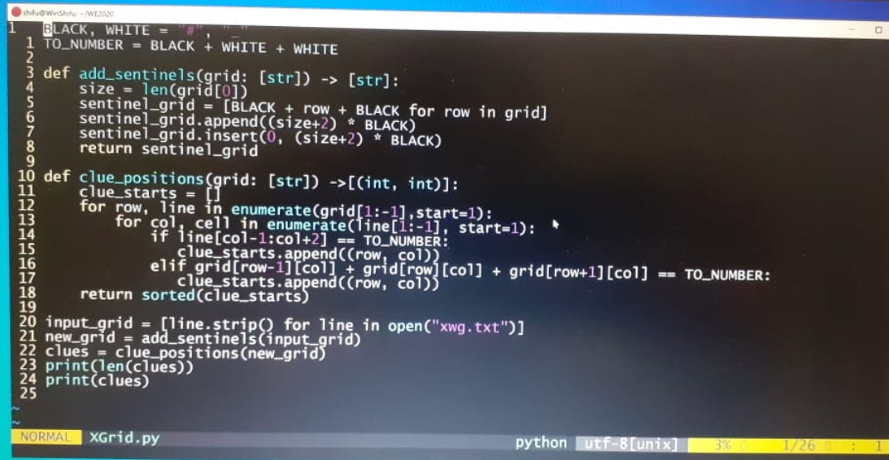

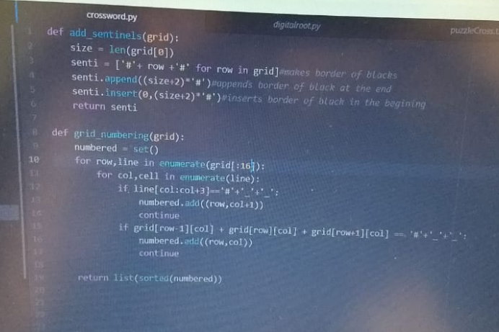

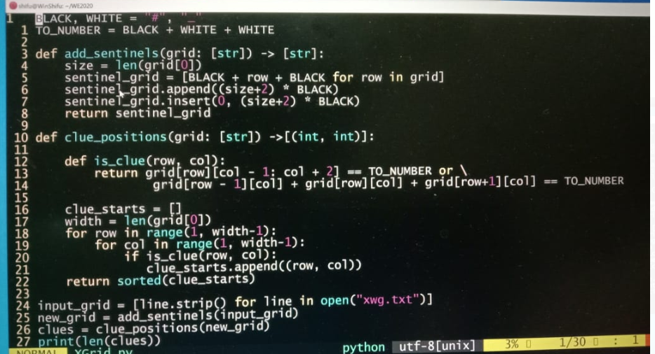

QUESTION 2

ROMAN TO NUMERAL

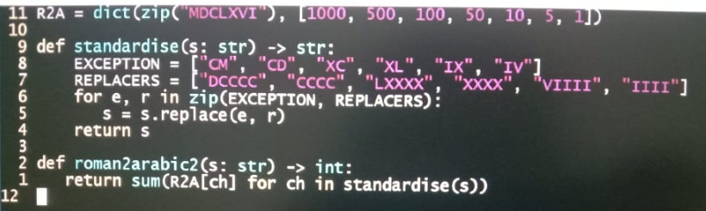

QUESTION 3

ODOMETER

This odometer can only show digits 1-9 and only the readings that are in

ascending order are valid. The first valid 4 digit reading is 1234 and the last is

6789. 2467 is valid, while 2314 is not. The odometer rolls over to the first valid

reading after the last.

Note: Size of odometer can be of any length

Write a set of functions which allow us to carry out the functionalities of the

odometer.

CODE -

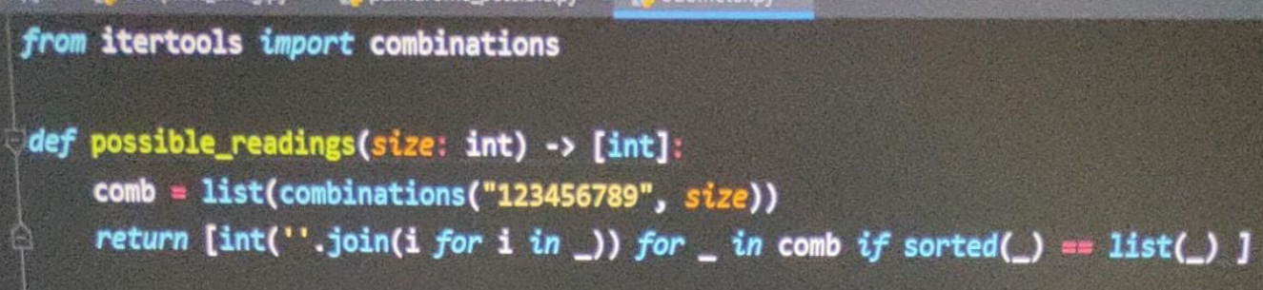

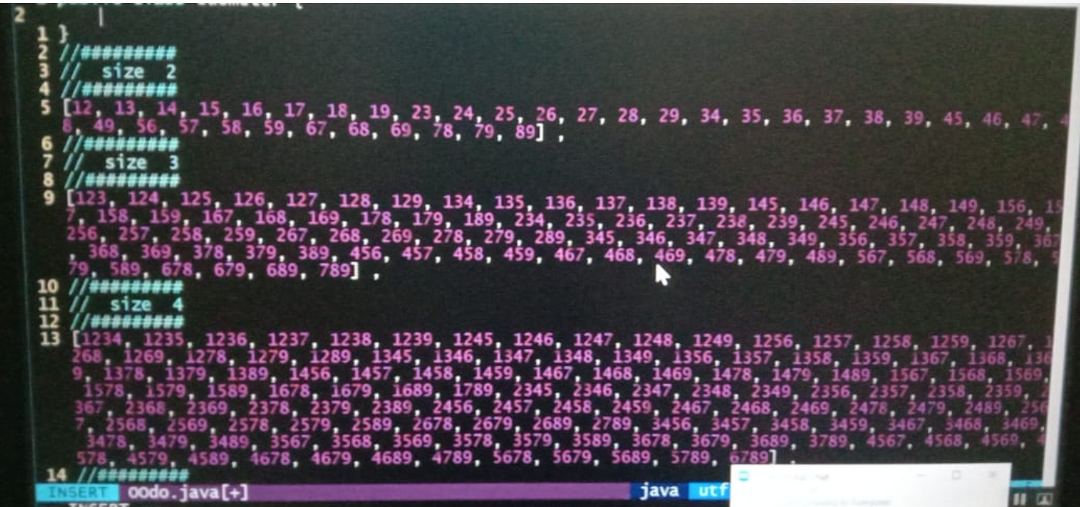

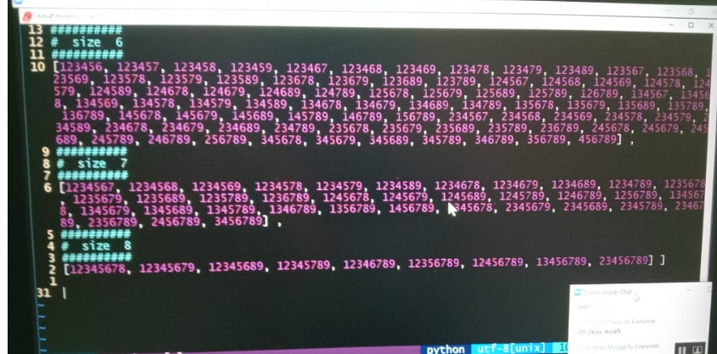

def number_in_increasing_order(reading:int) -> int:

reading = list(map(str , sorted(list(str(reading)))))

return(int(''.join(reading)))

def start_and_end(current_reading : int):

n = len(str(current_reading))

start = int(''.join(list(map(str , [*range(1, n+1)]))))

end = int(''.join(list(map(str , [*range((10-n), 10)]))))

return(start ,end)

def no_duplicates(current_reading:int) -> bool:

return(len(set(str(current_reading))) == len(str(current_reading)))

def odometer(current_reading :int) -> list:

start , end = start_and_end(current_reading)

iteration = start

while(iteration != end + 1):

if number_in_increasing_order(iteration) == iteration and iteration % 10 != 0 and no_duplicates(iteration):

if iteration > end:

iteration = start

yield(iteration)

iteration = iteration+ 1

def reading(current_reading : int , nth_reading : int) ->int:

distance = list(odometer(current_reading))

index = (distance.index(current_reading)+ nth_reading)%len(distance)

return(distance[index])

def get_next_reading(current_reading : int , nth_reading : int) -> int:

return(reading(current_reading , 1))

def get_previous_reading(current_reading : int) -> int:

return(reading(current_reading , -1))

def get_next_nth_reading(current_reading:int , nth_reading : int) ->int:

return(reading(current_reading , nth_reading))

def get_previous_nth_reading(current_reading :int, nth_reading:int) -> int:

return(reading(current_reading , -1*nth_reading))

def readings_in_between(reading1 :int, reading2:int):

distance = list(odometer(reading1))

index = abs(distance.index(reading1) - distance.index(reading2))

if index >= len(distance):

return(abs(len(distance) - index-1) % len(distance))

else:

return(index-1)

OR

def odometer(size: int)-> [int]:

if size == 9:

return [123456789]

if size == 1:

return [1, 2, 3, 4, 5, 6, 7, 8, 9]

start, end = start_and_end_readings(size)

odometer_readings = [start]

while start <= end:

start += 1

if valid_reading(start) and no_duplicates_in_reading(start):

odometer_readings.append(start)

return odometer_readings

def start_and_end_readings(size: int)-> (int):

start = int(''.join([str(x) for x in range(1, size + 1)]))

end = int(''.join([str(x) for x in range(10 - size, 10)]))

return start, end

def valid_reading(reading: int)-> bool:

return ''.join(sorted(str(reading))) == str(reading) and all([ch in '123456789' for ch in str(reading)])

def no_duplicates_in_reading(reading: int)-> bool:

return len(set(str(reading))) == len(str(reading))

def current_distance(current_reading: int)-> int:

return odometer(len(str(current_reading))).index(current_reading) + 1

def nth_readings(reading, n = 1)-> (int):

reading_list = odometer(len(str(reading)))

i = reading_list.index(reading)

previous_nth = reading_list[i - n]

if i + n > len(reading_list) - 1:

next_nth = reading_list[n - 1]

else:

next_nth = reading_list[i + n]

return previous_nth , next_nth

def distance_between_readings(initial, final: int)-> int:

return current_distance(final) - current_distance(initial)

print('''enter 1 for current distance

enter 2 for previous nth and next nth reading

enter 3 for previous and next reading

enter 4 for distance between two readings''')

choice = int(input())

if choice == 1:

reading = int(input("enter reading = "))

print(current_distance(reading))

elif choice == 2:

reading, n = input("enter reading, n = ").split()

print(nth_readings(int(reading), int(n)))

elif choice == 3:

reading = int(input('enter reading= '))

print(nth_readings(reading))

else:

initial , final = input("enter 2 readings = ").split()

print(distance_between_readings(int(initial), int(final)))

OR

public class Odometer {

static String digits = "123456789";

private int SIZE;

private int START;

private int LIMIT;

private int reading;

public static void main(String[] args) {

Odometer o = new Odometer(Integer.parseInt(args[0]));

o.debug();

o.next();

o.debug();

o.next(10);

o.debug();

o.prev(7);

o.debug();

o.prev(6);

o.debug();

Odometer p = new Odometer(o);

o.next(12);

System.out.println(p.distance(o));

}

private void debug() {

System.out.println(this.START + " << " + this.reading + " >> " + this.LIMIT);

}

public Odometer(int size) {

this.SIZE = size;

this.START = Integer.parseInt(Odometer.digits.substring(0, size));

this.LIMIT = Integer.parseInt(digits.substring(9 - size));

this.reading = this.START;

}

public Odometer(Odometer o) {

this.START = o.START;

this.LIMIT = o.LIMIT;

this.reading = o.reading;

}

private static boolean isAscending(int n) {

if (n < 10) return true;

if (n % 10 <= (n / 10) % 10) {

return false;

}

return isAscending(n / 10);

}

public void next() {

if (this.reading == this.LIMIT) {

this.reading = this.START;

return;

}

do {

++this.reading;

} while (!isAscending(this.reading));

return;

}

public void next(int n) {

for (int i = 0; i < n; ++i) {

this.next();

}

return;

}

public void prev() {

if (this.reading == this.START) {

this.reading = this.LIMIT;

return;

}

do {

--this.reading;

} while (!isAscending(this.reading));

return;

}

public void prev(int n) {

for (int i = 0; i < n; ++i) {

this.prev();

}

return;

}

public int distance(Odometer o) {

int diff = 0;

Odometer copy = new Odometer(this);

while (o.reading != copy.reading) {

copy.next();

++diff;

}

return diff;

}

}

QUESTION 4

TENNIS SCORE

Given a string “ABABABAAB”, saying which player(A or B) scored that point,

print the current score.

The current score for the given example is

player: A B

sets: 0 0

games: 1 0

points: 0 15

Note: To solve the above problem read about how to calculate the tennis score

CODE-

def tennisScores(string:str)->str:

scores = {'A':0 , 'B':0}; games = {'A':0 , 'B':0}

sets = {'A':0 , 'B':0}

isdeuce = False

advantage = None

for ch in string:

if isdeuce :

advantage = ch

isdeuce = False

scores[ch] += 1

elif advantage == ch:

scores['A'] = 0

scores['B'] = 0

games[ch] += 1

else:

scores[ch] += 1

if scores['A'] == scores['B'] and scores[ch] >= 3:

isdeuce = True

elif scores[ch] > 3:

games[ch] += 1

scores, isdeuce, advantage = initialize(scores, isdeuce, advantage)

games, sets = updateset(ch, scores, games, sets)

if scores['A'] > 3 or scores['B'] > 3:

scores['A'], scores['B'] = 0, 0

return sets, games, scores

def updateset(ch, scores, games, sets):

if games[ch] == 6:

sets[ch] += 1

games['A'], games['B'] =0, 0

return games, sets

return games, sets

def initialize(scores, isdeuce, advantage):

scores['A'], scores['B'] = 0, 0

isdeuce = False

advantage = "none"

return scores, isdeuce, advantage

OR

POINTS = [0, 15, 30, 40]

def setupdate(sets, games, ch):

if games[ord(ch) - 65] >= 6 and abs(games[0] - games[1]) >= 2:

sets[ord(ch) - 65]+=1

games[0] = games[1] = 0

return sets, games

def gameupdate(games: [int], points: [int], ch: chr) -> [int]:

if abs(points[0] - points[1]) >= 2 and points[ord(ch) - 65] >= 4:

games[ord(ch) - 65] += 1

points[0] = points[1] = 0

return games, points

def pointupdate(points: [int], ch: chr) -> [int]:

points[ord(ch) - 65] += 1

if points[0] == points[1] == 4:

points[0] = points[1] = 3

return points

def scoreupdate(points: [int]) -> str:

if points[1] == points[0] == 3:

return 'DEUCE'

if points[0] >= 4 and points[0] - points[1] == 1:

return 'AD 40'

if points[1] >= 4 and points[1] - points[0] == 1:

return '40 AD'

return str(POINTS[points[0]]) + ' ' + str(POINTS[points[1]])

def tennis(s:str) -> tuple:

games = [0, 0]

sets = [0, 0]

points = [0, 0]

for ch in s:

points = pointupdate(points, ch)

if points[0] >= 4 or points[1] >= 4:

games, points = gameupdate(games, points, ch)

if games[0] >= 6 or games[1] >= 6:

sets, games = setupdate(sets, games, ch)

score = scoreupdate(points)

return sets, games, score

print('Player: A B')

sets, games, points = tennis(input())

print('SETS: {} {}'.format(sets[0], sets[1]))

print('GAMES: {} {}'.format(games[0], games[1]))

print('POINTS: {}'.format(points))

OR

public class TennisScore {

private int aSets;

private int bSets;

private int aGames;

private int bGames;

private int aPoints;

private int bPoints;

private String scoreLine;

public TennisScore() {

this.aSets = 0;

this.bSets = 0;

this.aGames = 0;

this.bGames = 0;

this.aPoints = 0;

this.bPoints = 0;

this.scoreLine = "";

}

private int max(int x, int y) {

return x > y ? x : y;

}

private int abs(int x) {

return x > 0 ? x : -x;

}

private boolean gameOver() {

return max(this.aPoints, this.bPoints) >= 4

&& abs(this.aPoints - this.bPoints) >= 2;

}

private boolean setOver() {

return max(this.aGames, this.bGames) >= 6

&& abs(this.aGames - this.bGames) >= 2;

}

public void update(char ptWinner) {

if (ptWinner == 'A') {

this.aPoints += 1;

} else {

this.bPoints += 1;

}

if (gameOver()) {

if (aPoints > bPoints) {

this.aGames += 1;

} else {

this.bGames += 1;

}

this.aPoints = this.bPoints = 0;

if (setOver()) {

if (this.scoreLine.length() > 0) {

this.scoreLine += "; ";

}

this.scoreLine += aGames + " - " + bGames;

if (aGames > bGames) {

this.aSets += 1;

} else {

this.bSets += 1;

}

this.aGames = this.bGames = 0;

}

}

}

private String scoreName() {

String ptNames[] = {"Love", "Fifteen", "Thirty", "Forty"};

if (max(aPoints, bPoints) > 3) {

if (aPoints == bPoints) {

return "Deuce";

} else if (aPoints > bPoints) {

return "Adv A";

} else {

return "Adv B";

}

} else if (aPoints == bPoints) {

return ptNames[aPoints] + " All";

} else {

return ptNames[aPoints] + " " + ptNames[bPoints];

}

}

public String status() {

return scoreLine + aGames + " : " + bGames + " :: " + scoreName();

}

public void display() {

System.out.println(this.status());

}

public static void main(String[] args) {

TennisScore t = new TennisScore();

for (int i = 0; i < args[0].length(); ++i) {

char ch = args[0].charAt(i);

t.display();

t.update(ch);

}

t.display();

}

}

QUESTION 5

HOW TO TEST CODE IN PYTHON

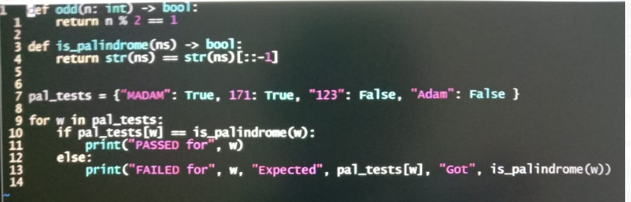

QUESTION 6

GOOD C CODE

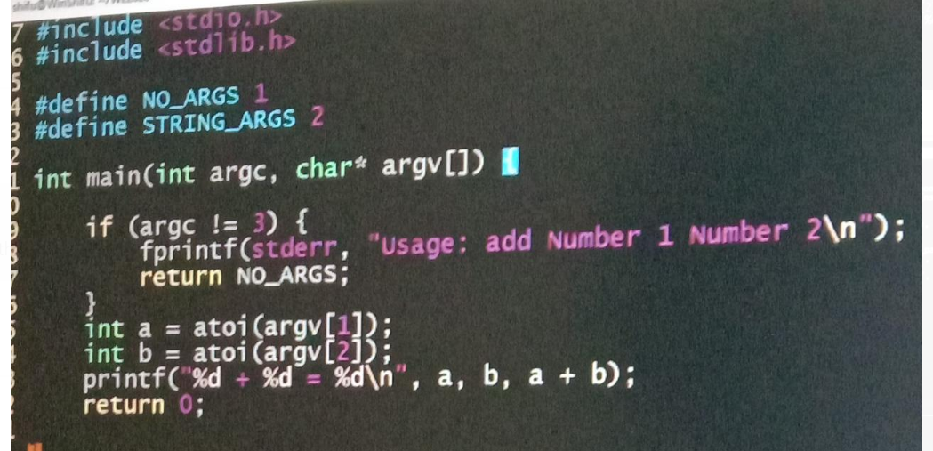

QUESTION 7

Given a word, create a function which returns whether or not it’s possible to create a palindrome by rearranging the letters in the word.

**Examples**

is_palindrome_possible(“rearcac”) - True # You can make “racecar”

is_palindrome_possible(“suhbeusheﬀ”) - True # You can make “sfuehbheufs”

(not a real word but still a palindrome)

is_palindrome_possible(“palindrome”) - False # It’s impossible

**Note**

• Trivially, words which are already palindromes return True.

• Words are given in all lowercase.

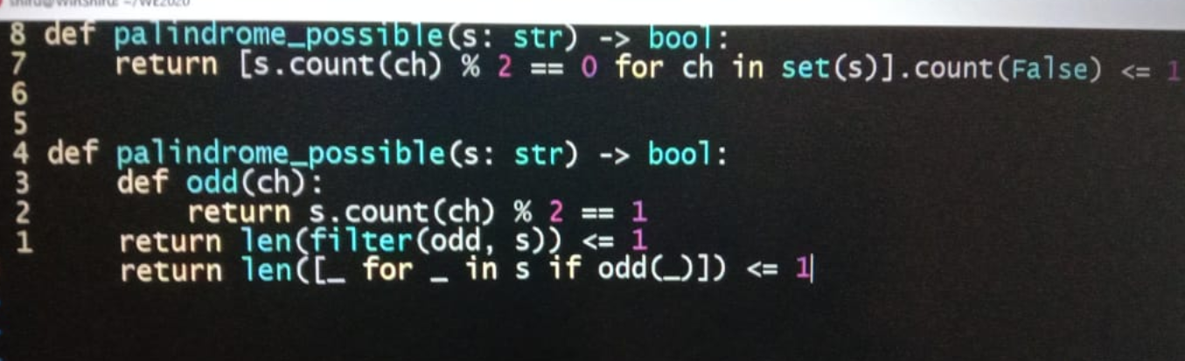

def canFormPalindrome(strr):

listt = []

# For each character in input strrings,

# remove character if listt contains

# else add character to listt

for i in range(len(strr)):

if (strr[i] in listt):

listt.remove(strr[i])

else:

listt.append(strr[i])

# if character length is even listt is expected to be empty

# or if character length is odd listt size is expected to be 1

if ((len(strr)% 2 == 0 and len(listt) == 0) or

(len(strr) % 2 == 1 and len(listt) == 1)):

return True

else:

return False

n=input()

if (canFormPalindrome(n)):

print("Yes")

else:

print("No")

QUESTION 8 –

TIME DIFFERENCE

You're given a string city_a and the related string timestamp (time in city_a) with the date formatted in full U.S. notation, as in this example:

"July 21, 1983 23:01"

You have to return a new timestamp with date and corresponding time in city_b, formatted as in this example:

"1983-7-22 23:01"

See the table below for a list of given cities and their GMT (Greenwich Mean Time) hours offsets.

GMT City

-08:00 Los Angeles

-05:00 New York

-04:30 Caracas

-03:00 Buenos Aires

00:00 London

+01:00 Rome

+03:00 Moscow

+03:30 Tehran

+05:30 New Delhi

+08:00 Beijing

+10:00 Canberra

Input: String, String, String

Output: String

**Examples**

time_difference("Los Angeles", "April 1, 2011 23:23", "Canberra") - "2011-4-2 17:23" # Can be a new day.

time_difference("London", "July 31, 1983 23:01", "Rome") - "1983-8-1 00:01" # Can be a new month.

time_difference("New York", "December 31, 1970 13:40", "Beijing") - "1971-1-1 02:40" # Can be a new year.

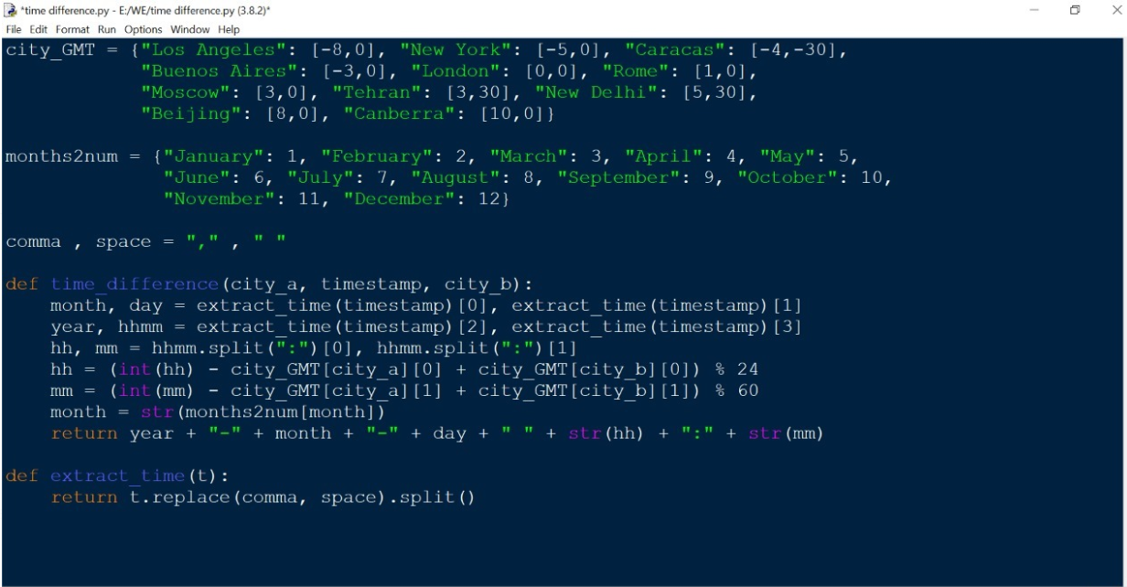

import datetime as dt

cities = {"Los Angeles": 0, "New York": 180, "Caracas": 210, "Buenos Aires": 300, "London": 480, "Rome": 540,

"Moscow": 660, "Tehran": 690, "New Delhi": 810, "Beijing": 960, "Canberra": 1080}

months = ["", "January", "February", "March", "April", "May", "June", "July", "August", "September", "October",

"November", "December"]

COMMA = ","

SPACE = " "

def get_timestamp(s: str):

s = s.replace(COMMA, SPACE).split()

s = dt.datetime(int(s[2]), months.index(s[0]), int(s[1]), int(s[3][:2]), int(s[3][3:]))

return s

def time_difference(city_a, timestamp, city_b):

difference = cities[city_b] - cities[city_a])

timestamp1 = get_timestamp(timestamp)

return timestamp1 + dt.timedelta(minutes=difference)

or

from datetime import datetime , timedelta

MONTHS = [0,'Jan' , 'Feb' ,'Mar' , 'Apr' , 'May' ,'Jun' , 'Jul' , 'Aug' , 'Sep' , 'Oct' , 'Nov','Dec']

MONTH_NUMBER = ['0','01','02','03','04','05','06','07','08','09','10','11','12']

def time_difference_between_timezones(city_a , city_b):

time_zones = {'Los Angeles' : -480 , 'Carcas' : -270 , 'New York':-300 , 'Buenos Aires' : -180 , 'London' : 0 , 'Rome':60 , 'Moscow' : 180 , 'Tehran' : 210 , 'New Delhi': 330 , 'Beijing' : 480 , 'Canberra' : 600}

return(time_zones[city_b] - time_zones[city_a])

def time_in_another_zone(datetime_str,city_a , city_b ):

change_time = time_difference_between_timezones(city_a , city_b)

time_in_another_zone = datetime_str + timedelta(minutes = change_time)

return(str(time_in_another_zone))

def time_difference(city_a, timestamp, city_b):

timestamp = [i.strip(',') for i in timestamp.split()]

month = timestamp[0].capitalize()[:3]

timestamp[0] = MONTH_NUMBER[MONTHS.index(month)]

datetime_str= timestamp[2]+'-'+timestamp[0]+'-'+timestamp[1] + ' ' + timestamp[3]

datetime_str = datetime.strptime(datetime_str, '%Y-%m-%d %H:%M')

return(time_in_another_zone(datetime_str , city_a , city_b)[:-3])

~Namya LG

Or

import datetime as dt

GMT_TIME = {

"Los Angeles": 0,

"New York": 180,

"Caracas": 210,

"Buenos Aires": 300,

"London": 480,

"Rome": 540,

"Moscow": 660,

"Tehran": 690,

"New Delhi": 810,

"Beijing": 960,

"Canberra": 1080,

}

MONTH = ['',

'JANUARY', 'FEBRARY', 'MARCH',

'APRIL', 'MAY', 'JUNE',

'JULY', 'AUGUST', 'SEPTEMBER',

'OCTOBER', 'NOVEMBER', 'DECEMBER']

COMMA = ','

SPACE = " "

def change_timestamp(year, mon, date, hour, minute):

return dt.datetime(year, MONTH.index(mon), date, hour, minute)

def time_difference(city_a, timestamp, city_b):

min_difference = GMT_TIME[city_b] - GMT_TIME[city_a]

mon, date, year, time = timestamp.replace(COMMA, SPACE).split()

hour, minute = time.split(':')

timestamp = change_timestamp(

int(year), mon.upper(), int(date), int(hour), int(minute))

# print(timestamp)

return str(timestamp + dt.timedelta(minutes=min_difference))[:-3]

QUESTION 9 –

XOR

**Given a string consisting of only 0, 1, A, B, C where**

**A = AND**

**B = OR**

**C = XOR**

**Write a function to calculate the value of the string assuming no order of precedence and evaluation is done from left to right.**

**Note:**

**Return -1, if the string is not a valid string. For example, '1AA0' is not a valid string and '1C1B1B0A0' is a valid string.**

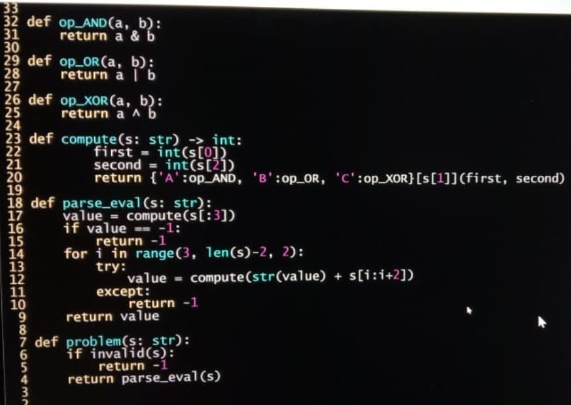

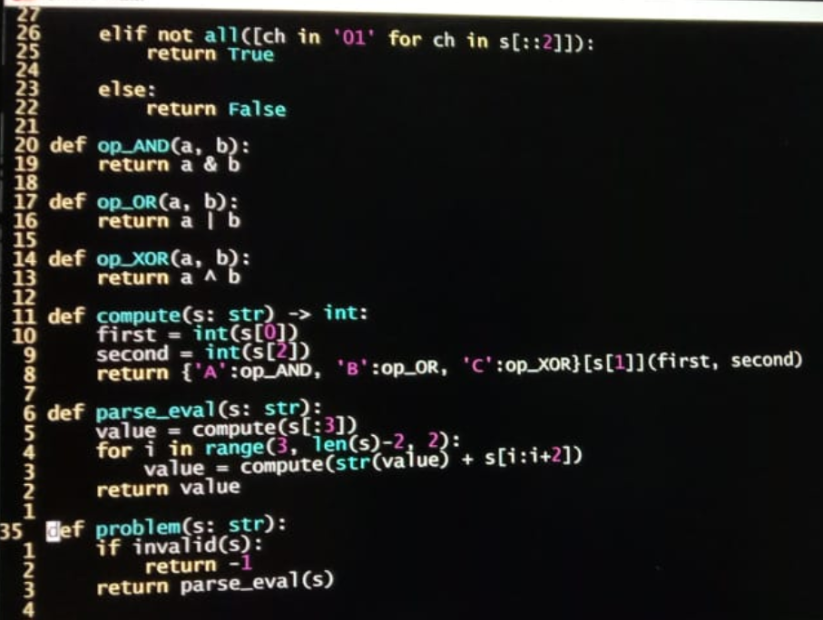

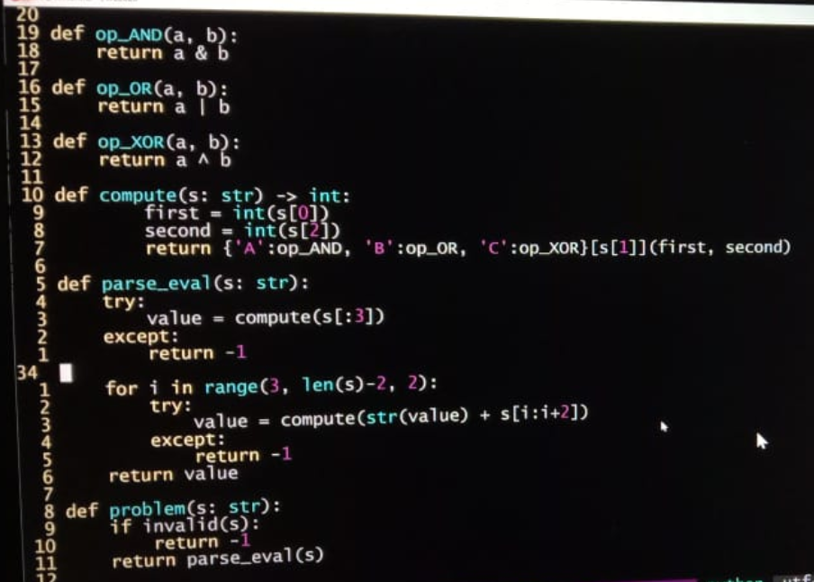

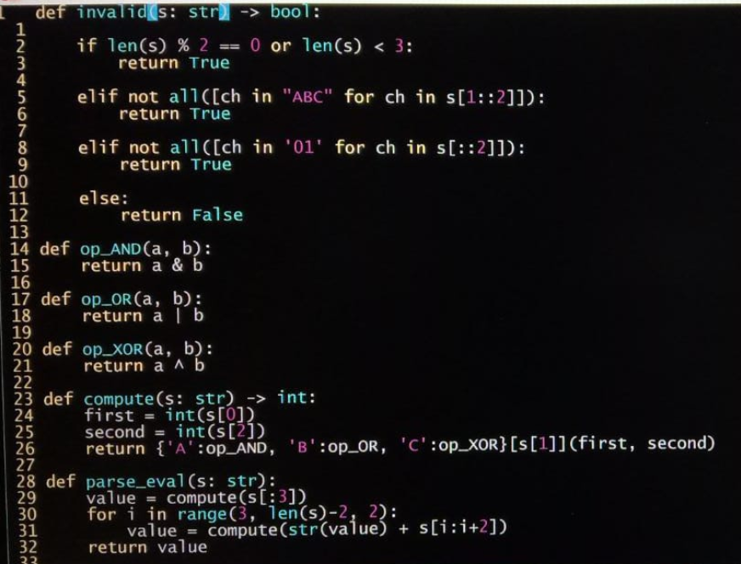

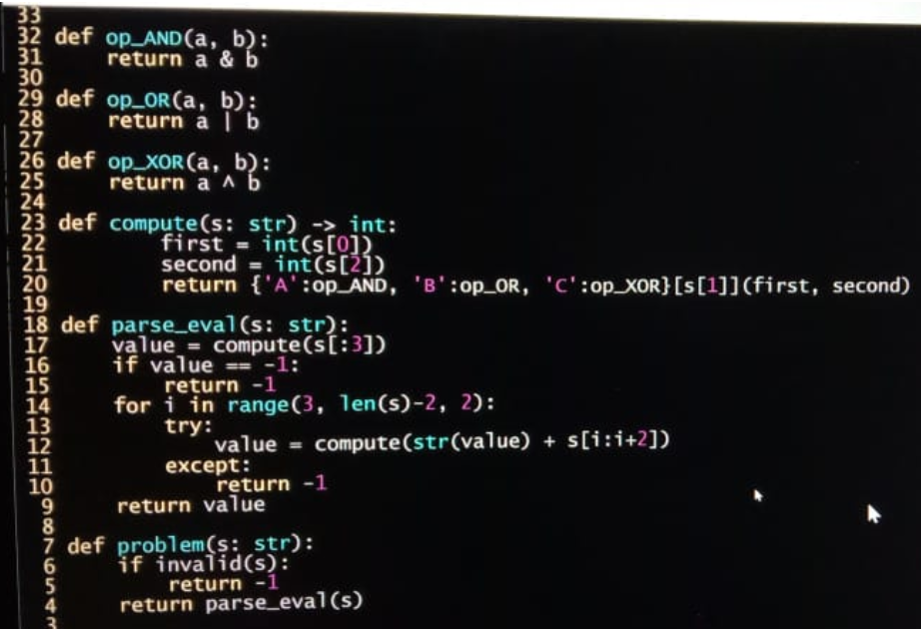

def Evaluating_String(string):

num = []

op = []

if( len(string) % 2 == 0):

return -1

for i in range(len(string)):

if(i%2 == 0):

if string[i] == '1' or string[i] == '0':

num += [int(string[i])]

else :

return -1

else :

if string[i] == 'A' or string[i] == 'B' or string[i] == 'C' :

op += [ord(string[i]) - 64]

else:

return -1

j = num[0]

for i in range (len(op)):

if(op[i] == 1 ):

j = j & num[i+1]

elif(op[i] == 2):

j = j | num[i+1]

else:

j ^= num[i+1]

return j

QUESTION 10 –

ANAGRAMS

An anagram is a word formed by rearranging the letters of a different word,

typically using all the original letters exactly once.

For example, anagrams of word cat are tac, act.

Given an array of words, write a function to return a group anagrams.

Input: List of words

Output: List of list of words

Sample Input: [“tar”, “State”, “rat”, “art”, “Taste”, “dream”]

Sample Output: [[‘state’, ‘taste’], [‘dream’], [‘tar’, ‘rat’, ‘art’]

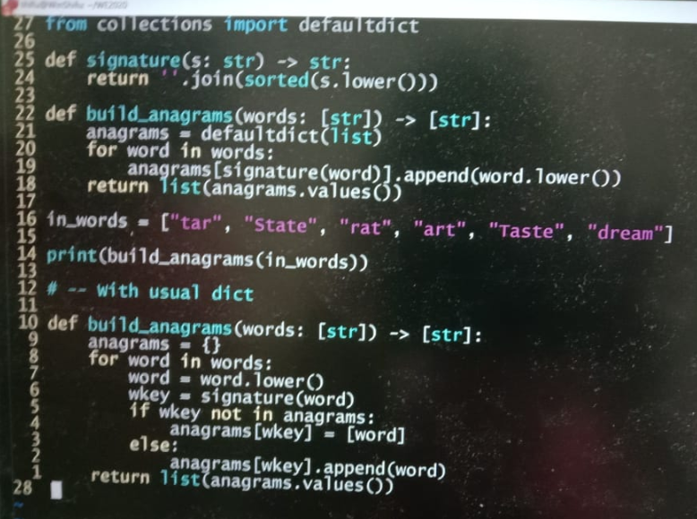

from collections import defaultdict

def lower(arr):

for i in range(len(arr)):

arr[i] = arr[i].lower()

return arr

def sorting(arr):

return sorted(arr,key = len)

def groupAnagrams(words):

words = sorting(words)

words = words[::-1]

words = lower(words)

words = sorting(words)

words = words[::-1]

groupedWords = defaultdict(list)

for word in words:

groupedWords["".join(sorted(word))].append(word)

k = []

for group in groupedWords.values():

k += [group]

return (k)

QUESTION 11 –

SPECIAL NUMBER

Write a function that returns True if a given number is a special number or else it should return False. A special number is a number if it is equal to the sum of the factorial of it's digits.

Input: Integer

Output: Integer

Sample Input: 145

Sample Output: True

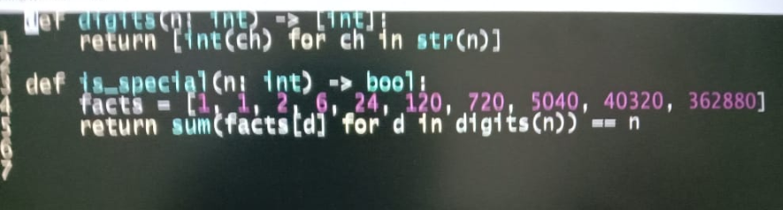

def IsSpecialNumber(n):

fact=1

sum1=0

num=n

while(num>0):

d=num%10

for i in range(1,d):

fact=fact*i

fact=fact*d

sum1=sum1+fact

fact=1

num=num//10

if(n==sum1):

return True

else:

return False

QUESTION 12 –

LETTERS MATCH IN THE STRING

Write a function that takes two strings and returns how many matches there are between the strings. A match is where the two strings have the same character at the same index.

Input: string 1, string 2

Output: Integer

Sample Input: "common", "come"

Sample Output: 3

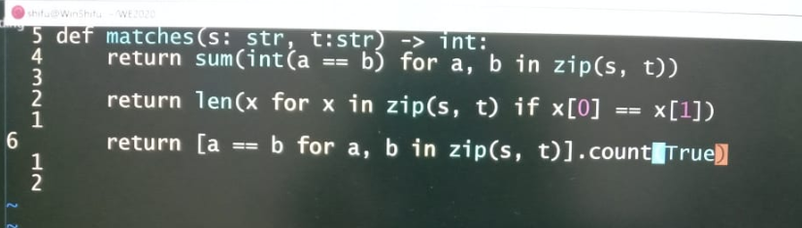

def matches(s1, s2):

cnt=0

k=min(len(s1),len(s2))

for i in range(k):

if s1[i]==s2[i]:

cnt+=1

return cnt

QUESTION 13 –

ENCRYPT STRING 1

Write a function that encrypts a given input with these steps:

Step 1: Reverse the input: "elppa"

Step 2: Replace all vowels using the following chart:

a => 0

e => 1

o => 2

u => 3

Step 3: Add "aca" to the end of the word

Input: String

Output: String

Sample Input: 'apple'

Sample Output: "1lpp0aca"

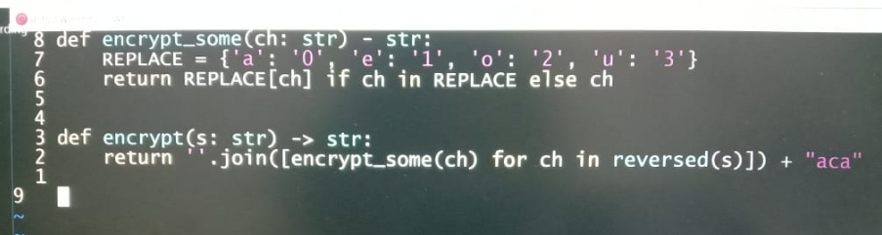

def encrypt(input_word):

input_word=rev(input_word)

input_word=vow(input_word)

input_word=suf(input_word)

return input_word

def rev(input_word):

return input_word[::-1]

def vow(input_word):

for i in range(len(input_word)):

k=input_word[i]

if(k=='a' or k=='A'):

input_word=input_word.replace(k,'0')

if(k=='e' or k=='E'):

input_word=input_word.replace(k,'1')

if(k=='o' or k=='O'):

input_word=input_word.replace(k,'2')

if(k=='u' or k=='U'):

input_word=input_word.replace(k,'3')

return input_word

def suf(input_word):

return input_word+"aca"

QUESTION 14 –

PRIMORIAL NUMBER

A Primorial is a product of the first n prime numbers (e.g. 2 x 3 x 5 = 30). 2, 3, 5, 7, 11, 13 are prime numbers. If n was 3, you'd multiply 2 x 3 x 5 = 30 or Primorial = 30.

Write a function that returns the Primorial of a number.

Input: Integer

Output: Integer

Sample Input: 3

Sample Output: 30

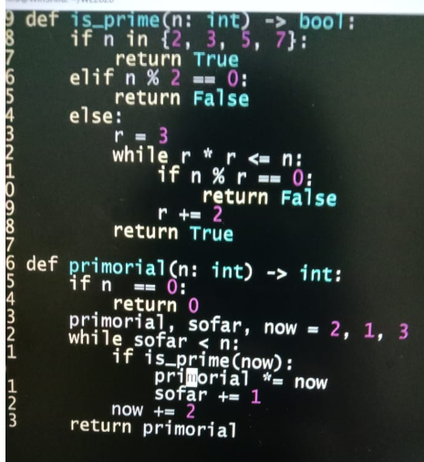

def prime(n):

if n==2:

return True

for i in range(2,n):

if n%i==0:

return False

return True

def getPrimoral(number):

p=1

j=0

i=2

if(number<=0):

return 0

while(j<number):

if(prime(i)):

p*=i

j+=1

i+=1

return p

QUESTION 15 –

ALIQUOT SUM

A positive integer d is said to be a factor of another positive integer N, when N is divided by d, the remainder obtained is zero.

For example, for number 12, there are 6 factors 1, 2, 3, 4, 6, 12.

Aliquot sum of a positive integer n is the sum of all proper divisors of n, that is, all divisors of n other than n itself.

Let f(n) be the aliquot sum. Write a function which takes a positive integer as input and returns

"Alpha" if f(n) < n

"Gamma" if f(n) == n and

"Beta" if f(n) > n

Input: Positive Integer

Output: String

Sample Input: 6

Sample Output: Gamma (Factor of 6 are 1, 2, 3 and sum of them is equals to 6)

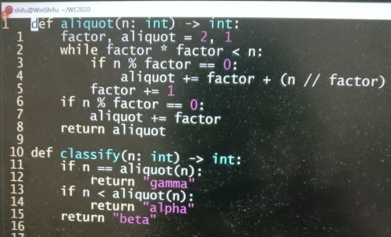

def aliquotSum(n):

sum1=1

for i in range(2,n//1):

if(n%i==0):

sum1=sum1+i

return sum1

def classify(n):

sum2=aliquotSum(n)

if sum2<n:

return "Alpha"

elif sum2==n:

return "Gamma"

elif sum2>n:

return "Beta"

QUESTION 16 –

DIGITAL ROOT

Write a function that returns the digital root of an integer n.

The digital root of a number n is obtained as follows: Add up the digits n to get a new number. Add up the digits of that to get another new number. Keep doing this until you get a number that has only one digit. That number is the digital root.

For example, if n = 45893 ,

add up the digits to get 4 + 5 + 8 + 9 + 3 = 29

add up the digits of 29 to get 2 + 9 = 11

add up the digits of 11 to get 1 + 1 = 2

since 2 being single digit, is the digital root.

Input: Integer

Output: Integer

Sample Input: 45893

Sample Output: 2

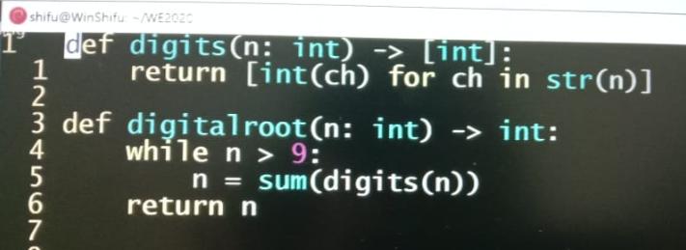

def digital_root(n):

sum1=0

if n>0 and n<=9:

return n

else:

while(n>0):

d=n%10

sum1=sum1+d

n=n//10

sum2=digital_root(sum1)

return sum2

QUESTION 17 –

ENCRYPT STRING 2

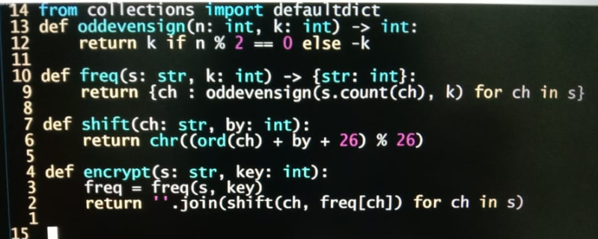

QUESTION 18 –

LEIBNITZ SERIES

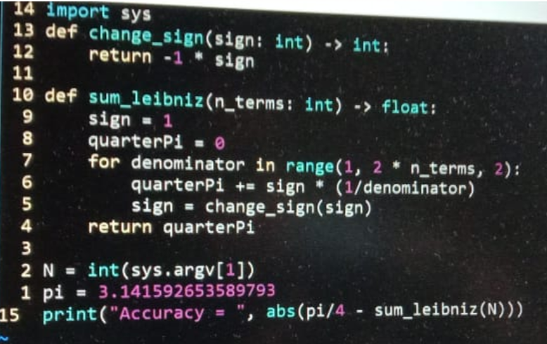

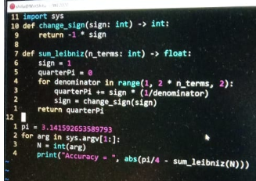

QUESTION 19 –

NUMBER OF ZEROS BETWEEN ONES

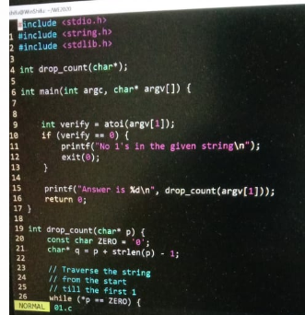

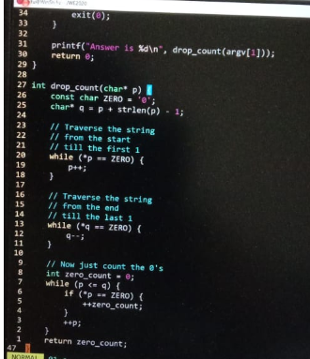

QUESTION 20-

CIRCULAR PRIME

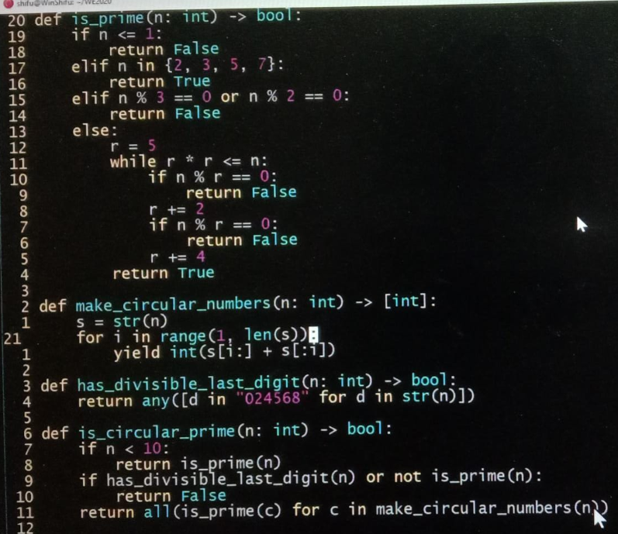

def isCircularPrime(num):

# YOUR CODE HERE

n=str(num)

if(n=='1' or n=='0'):

return False

k=2*n

b=len(k)//2

for i in range(b):

s=int(k[i:b+i])

if(Prime(s)!=True):

return False

return True

def Prime(n):

for i in range(2,n//2+1):

if (n%i==0):

return False

return True

QUESTION 21 –

JULIAN DATE

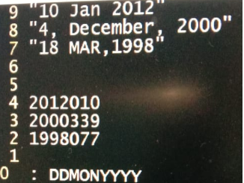

Input format is line 9,8,7....output format is line 4,3,2.....name of the yr followed by number of day of that yr....separator for the input can be comma, space or both

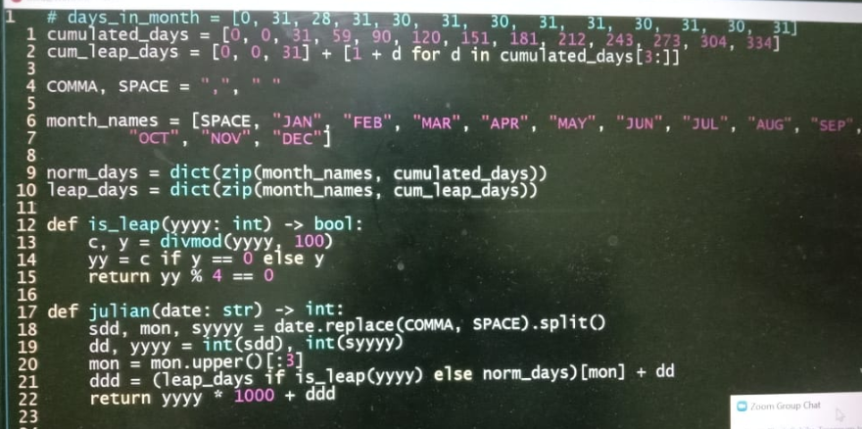

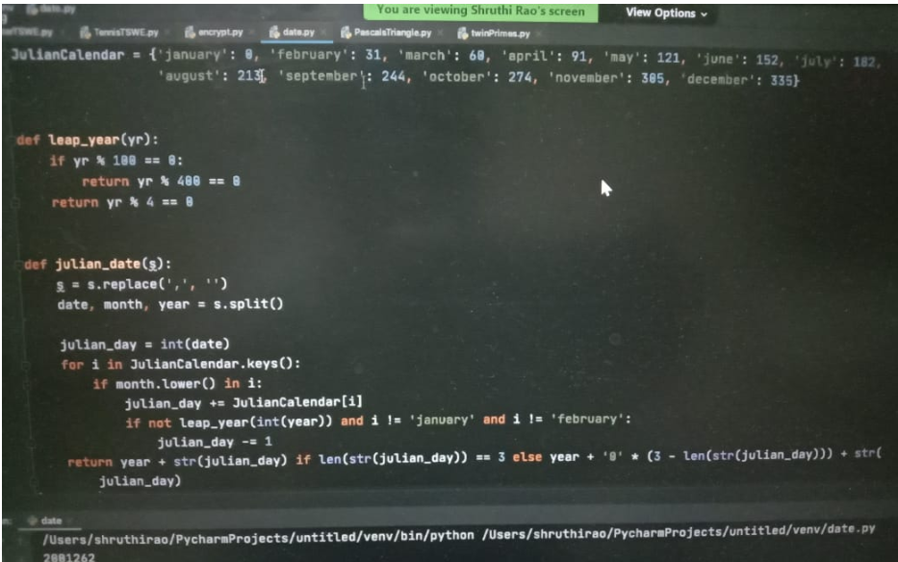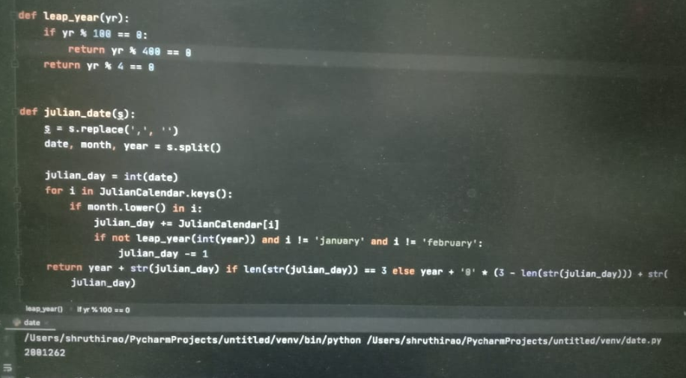

QUESTION 22 –

ROT – 13

ROT-13 is the encrypting of a message by exchanging each of the letters on the first half of the alphabet with the corresponding letter in the second half of the alphabet (that is, swapping positions by 13 characters). Thus, A becomes N, B becomes O, and so forth, and conversely, N becomes A, O becomes B, and so forth. Numbers, spaces and punctuation are not changed.

**Input:** this is a sentence

**Output:** guvf vf n fragrapr

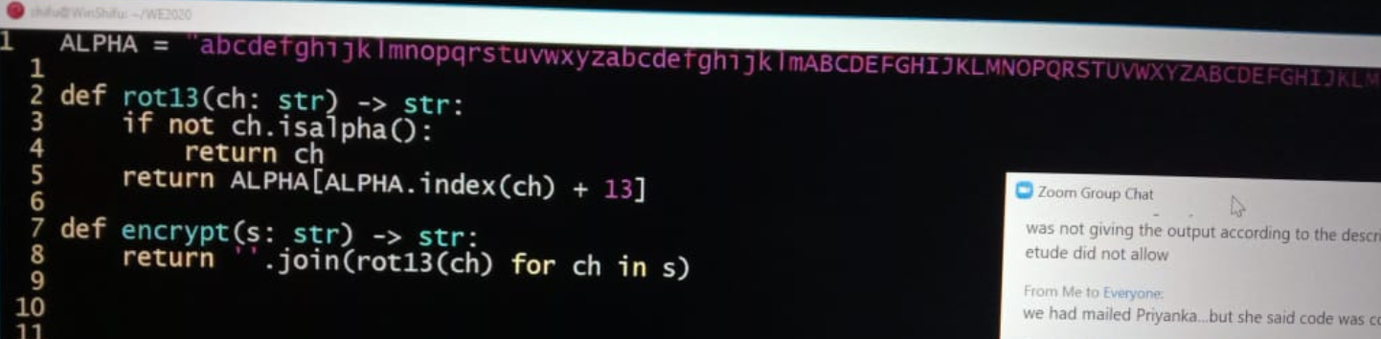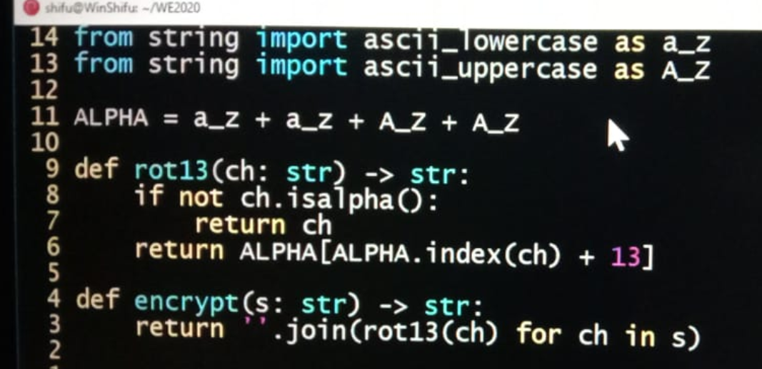

PROGRAM 23 –

PASCAL TRIANGLE

The goal of this program is to return Pascal's triangle up to number 29. Pascal's triangle is the sum of the two upper corners.

1 1

1 2 1

1 3 3 1

Create a function that returns a row from Pascal's triangle. To find the row and column you can use n!/(k!*(n-k)!) where n is the row down and k is the column

Input: Integer

Output: String

Sample Input: 4

Sample Output: "1 4 6 4 1"

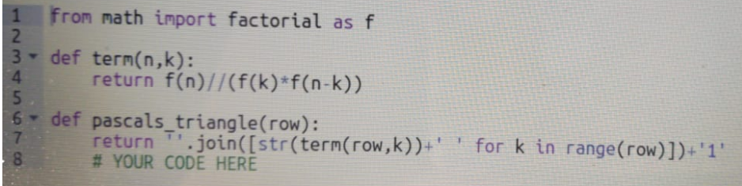

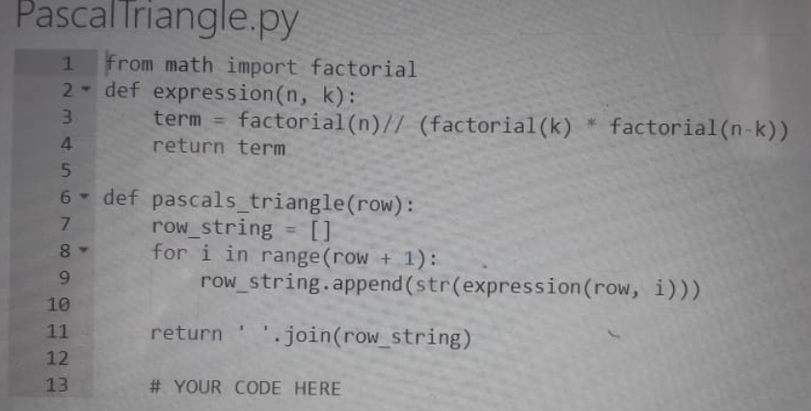

PROGRAM 24 –

TWIN PRIME

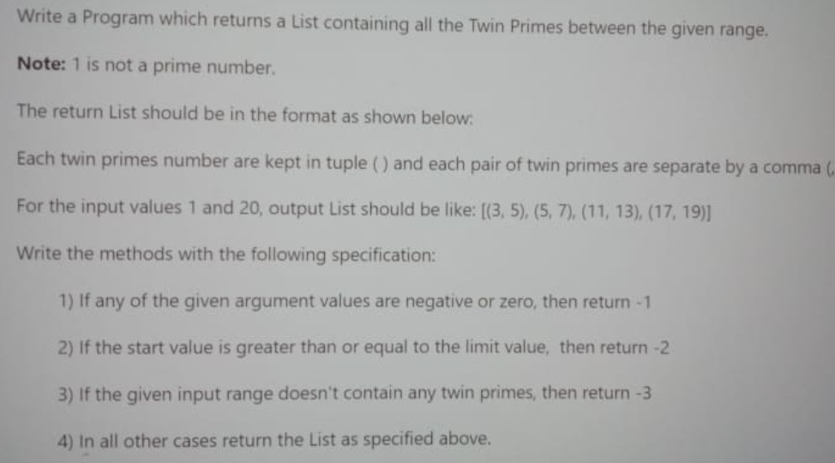

def isPrime(num):

if num==0 or num==1:

return False

for i in range(2,num):

if (num%i==0):

return False

return True

def twinPrimes(start, limit):

l=[]

if(start<=0 or limit<=0):

return -1

if(start>=limit):

return -2

for i in range(start+1,limit):

j=i+2

if(isPrime(i) and isPrime(j)):

tup=(i,j)

l.append(tup)

if (l==[]):

return -3

else:

return l

PROGRAM 25 –

KAPREKAR NUMBER

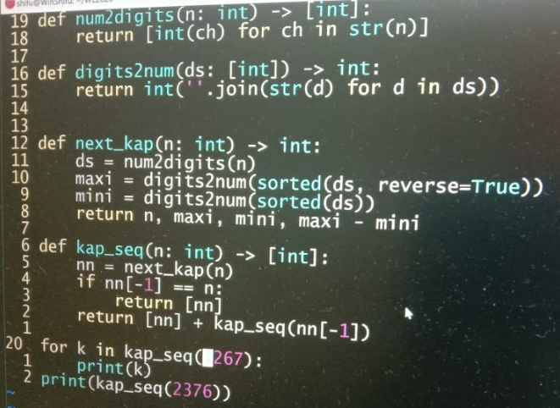

PROGRAM 26 –

ARMSTRONG IN RANGE

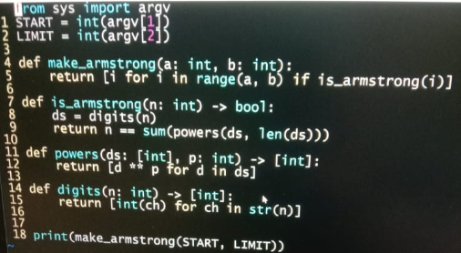

# armstrong numbers in range

import sys

def arm(n: [int]) -> bool:

temp = n

sum = 0

while(n):

r = n%10

sum += r**3

n //= 10

if sum == temp :

return True

return False

def arm_range(n) -> list:

l = []

for i in range(n+1):

if(arm(i)):

l += [i]

return l

PROGRAM 27 –

CHANGE VOWELS AND CONSONENTS WITH SYMBOLS

Write a function that transforms the input (array of three words) as follows:

* Replace all the vowels in first word by $

* Replace all consonants in second word by #

* Convert all characters in third word to upper case

* Then concatenate the three words

The function should return the concatenated string

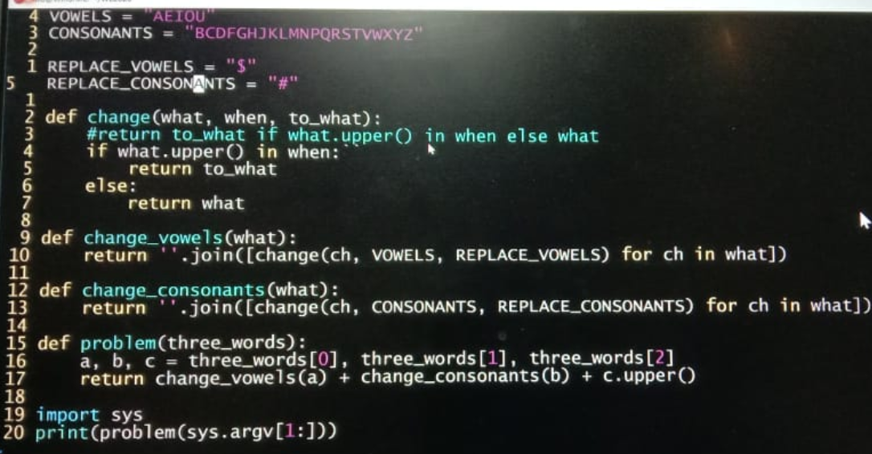

def stringTansformation(array):

a ="AEIOU"

for ch in a:

array[0] = array[0].replace(ch,"$").replace(ch.lower(),"$")

b = "BCDFGHJKLMNPQRSTVWXYZ"

for ch in b:

array[1] = array[1].replace(ch,"#").replace(ch.lower(),"#")

p = array[1]

q = array[2].upper()

return str(array[0]) + p + q

PROGRAM 28 –

RUSSIAN MULTIPLICATION

o multiply two numbers, say 18 and 85, write them in two columns. Divide the first column by 2 and multiply the second column by 2. When dividing ignore remainder, but if remainder is 1 make a PLUS mark against that row. Stop when first column is 1 (marking that row with a PLUS).

Now add all numbers in the second column, in those rows marked with a PLUS. The total is the product. Thus knowing to divide by 2, multiply by 2 and adding we can multiply any two numbers.

18 85

9 170 +

4 340

2 680

1 1360 +

============

1530

============

Write a program to accept the two numbers and generate the tableau.

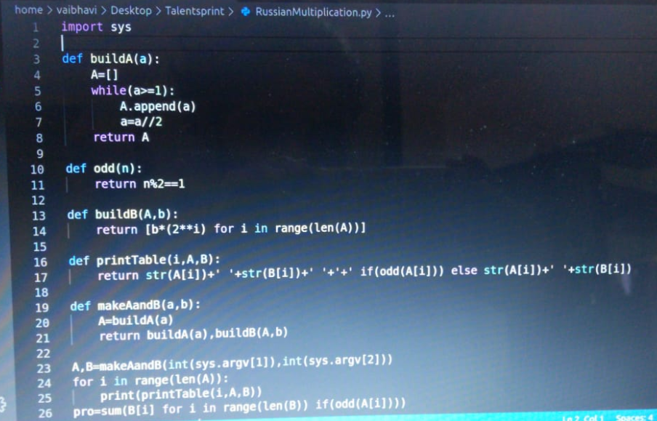

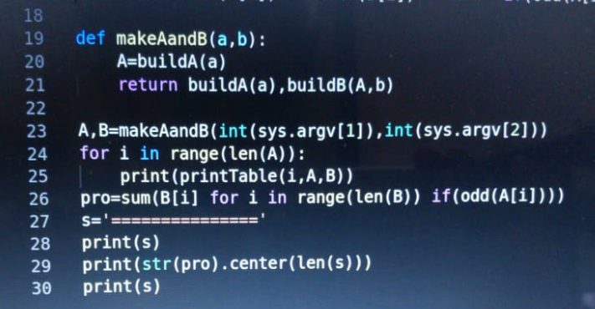

PROGRAM 29 –

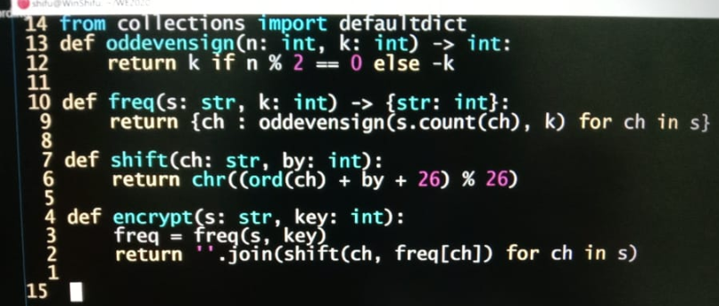

PROGRAM 30 –

PATTERNS

OUTPUT

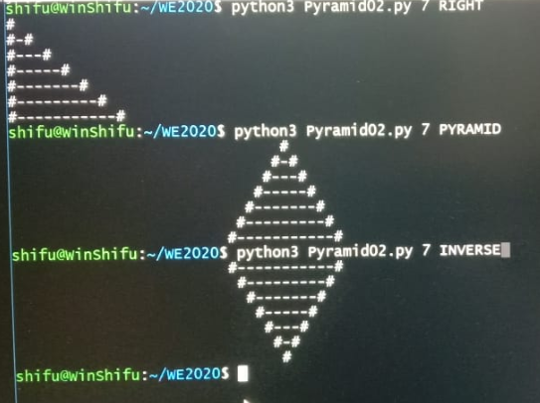

CODES

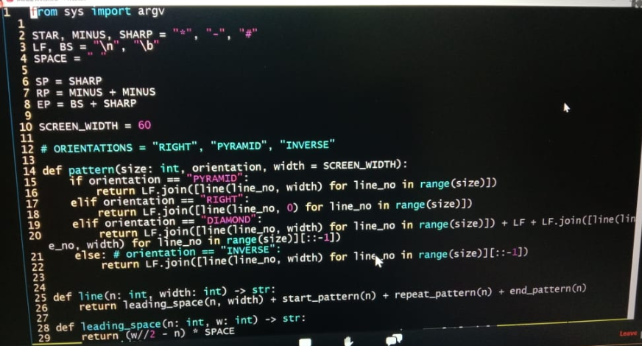

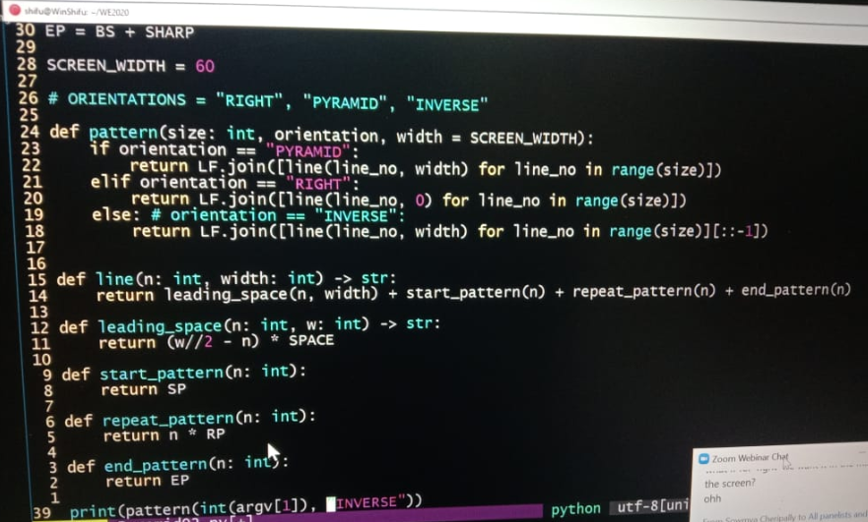

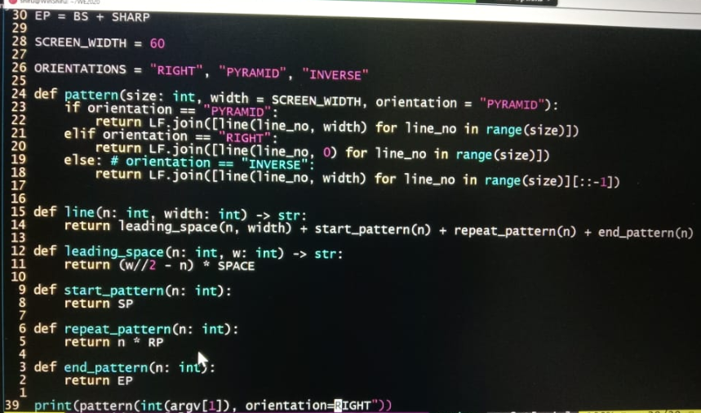

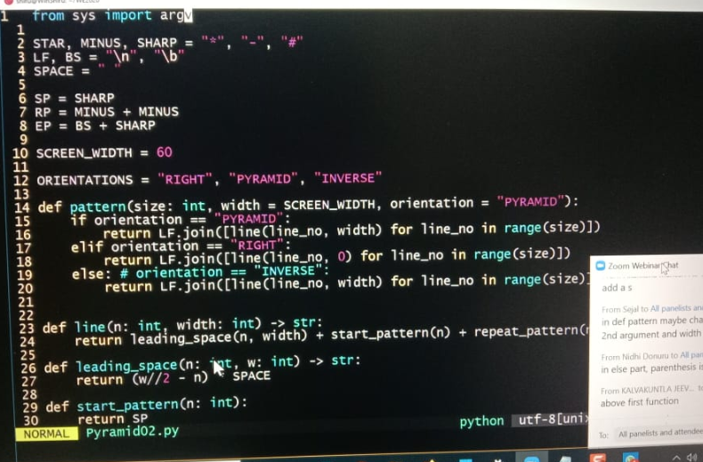

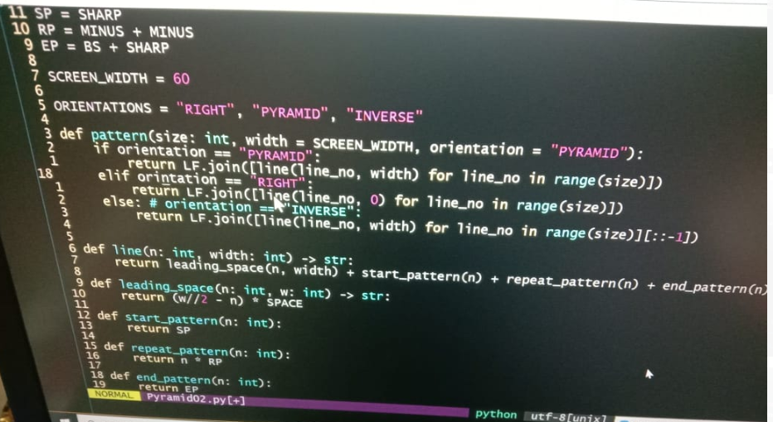

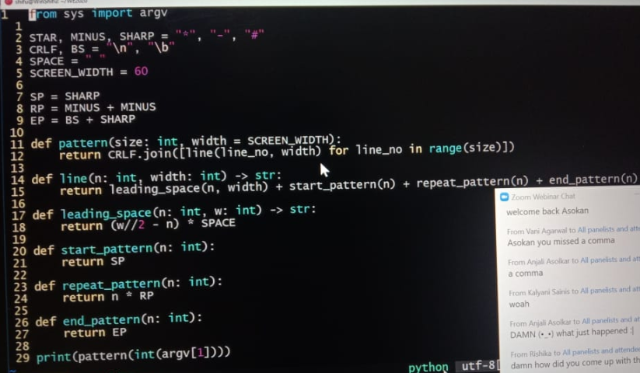

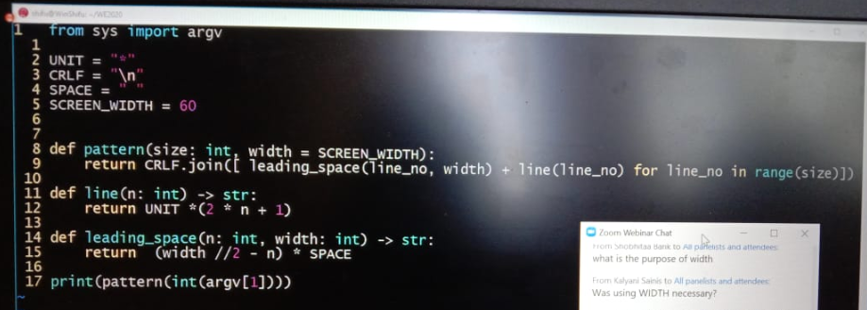

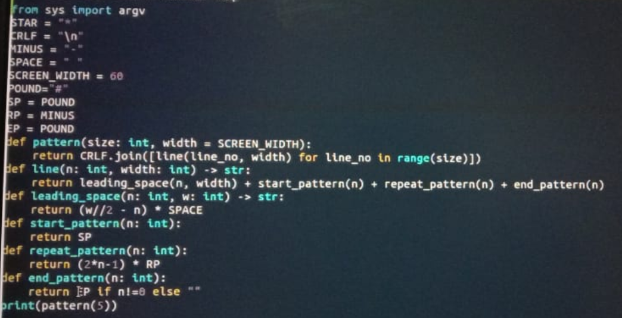

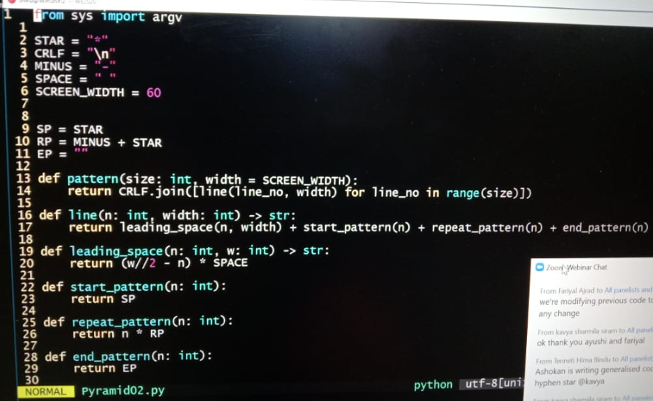

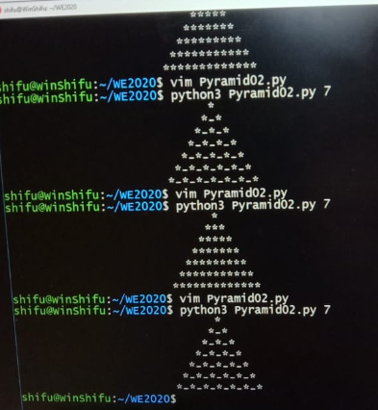

PROGRAM 31 –

SUBSETS

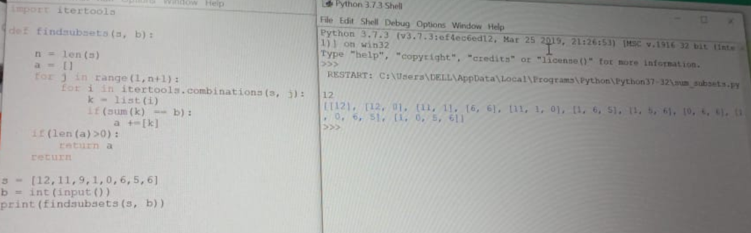

import itertools

def get_subset_for_sum(arr, k):

n=len(arr)

a=[]

for j in range(1,n+1):

for i in itertools.combinations(arr,j):

l=list(i)

if(sum(l)==k):

a+=[l]

if(len(a)>0):

return a[0]

return

OR

import itertools

def findsubsets(s, b):

s = [i.replace('[',"") for i in s]

s = [i.replace(']',"") for i in s]

for i in range(len(s)):

s[i] = int(s[i])

n = len(s)

a = []

for j in range(1,n+1):

for i in itertools.combinations(s, j):

k = list(i)

if(sum(k) == b):

a +=[k]

if(len(a)>0):

return a

return

s = list(map(str,input().split(",")))

b = int(input())

print(findsubsets(s, b))

PROGRAM 32 –

IS VOWEL

def isvowel(b : [list]) -> bool:

if(b == 'a' or b == 'e' or b =='i' or b =='o' or b == 'u' or b =='A' or b == 'E' or b == 'I' or b == 'O' or b == 'U'):

return True

return False

PROGRAM 33 –

FIND NUMBER OF TRAILING ZEROS

def trailing_zeros(n):

fact=1

for i in range(1,n+1):

fact=fact*i

string=str(fact)

no=len(string)-len(string.rstrip('0'))

return no

PROGRAM 34 –

SUM OF HOLES

What do the digits 0, 4, 6, 8, and 9 have in common? Well, they are whole numbers... and they are also hole numbers (not actually a thing until now). Hole numbers are numbers with holes in their shapes (8 is special in that it contains two holes).

14 is a hole number with one hole. 88 is a hole number with four holes.

Your task is to create a function with argument N that returns the sum of the holes for the integers n in the range of range 0 < n <= N.

Input: Integer

Output: Integer

Sample Input: 14

Sample Output: 7 (because there are 7 holes in 4, 6, 8, 9, 10 and 14.

CODE –

hole=[1,0,0,0,1,0,1,0,2,1]

def sum_of_holes(limit):

sum1=0

for i in range(1,limit+1):

sum1+=count_holes(i)

return sum1

def count_holes(num):

holes=0

while(num>0):

d=num%10

holes=holes+hole[d]

num=num//10

return holes

PROGRAM 35 –

PATTERN

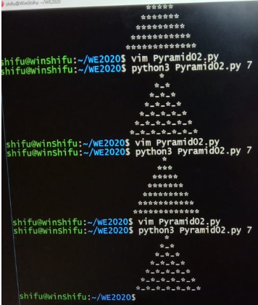

from sys import argv

STAR = "*"

CRLF = "\n"

MINUS = "-"

SPACE = " "

SCREEN_WIDTH = 60

SP = STAR

RP = MINUS + STAR

EP = ""

def pattern(size: int, width = SCREEN_WIDTH):

return CRLF.join([line(line_no, width) for line_no in range(size)])

def line(n: int, width: int) -> str:

return leading_space(n, width) + start_pattern(n) + repeat_pattern(n) + end_pattern(n)

def leading_space(n: int, w: int) -> str:

return (w//2 - n) * SPACE

def start_pattern(n: int):

return SP

def repeat_pattern(n: int):

return n * RP

def end_pattern(n: int):

return EP

print(pattern(int(argv[1])))

PROGRAM 36 –

DOUBLE BASE PALINDROME

#Palindrome number whose binary equivalent is also palindrome

def isDoubleBasePalindrome(n):

temp=n

m=0

while(temp>0):

m=(temp%10)+(m*10)

temp=int(temp/10)

if(m==n):

str=integer_string(m)

str1=str

if(str[::-1]==str1):

return True

return False

def integer_string(n):

str=""

while(n>0):

digit=n%2

n=int(n/2)

str=chr(digit+ord('0'))+str

return str

PROGRAM 37 –

COMPRESS STRING

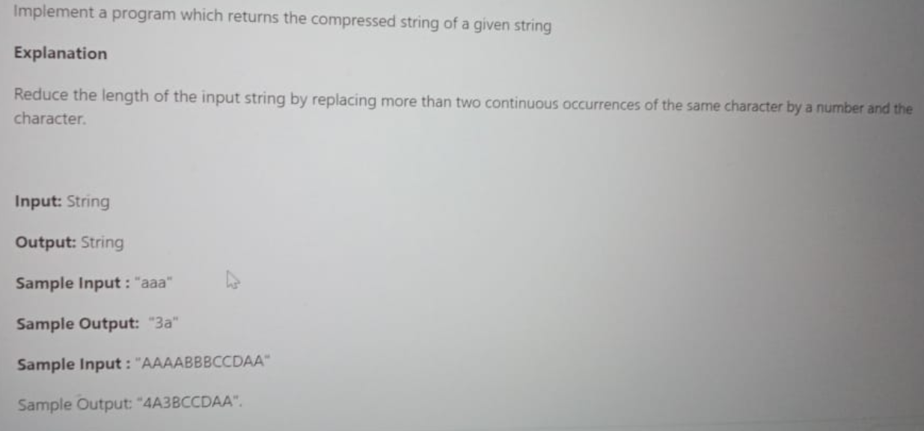

def compressString(s):

k=""

b=s

count=1

n=len(b)

for i in range(n):

if(i+1!=n and b[i]==b[i+1]):

count+=1

elif(count>=3):

k+=str(count)+b[i]

count=1

else:

for j in range(count):

k+=b[i]

count=1

if(count>=3):

k+=str(count)+b[i]

return k

OR

def fun(b):

k = ''

count = 1

n = len(b)

for i in range(n):

if(i+1 != n and b[i] == b[i+1]):

count += 1

elif(count >= 3):

k += str(count) +b[i]

count = 1

else:

for j in range(count):

k+=b[i]

count = 1

if(count >= 3):

k += str(count) +b[i]

return k

b = input()

print(fun(b))

PROGRAM 38 –

SUM OF UNIQUE ELEMENTS

def sum_unique():

sum=0

arr =[1,2,3,4,4,5,6,5,7,4,6,3]

for i in range(len(arr)):

if(arr.count(i)==1):

sum=sum+arr[i]

return sum

print(sum_unique())

or

def unique_sum(arr):

sum=arr[0]

curr=arr[0]

arr.sort()

for i in range (1, len(arr)):

if(curr!=arr[i]):

sum+=arr[i]

curr=arr[i]

print(sum)

arr=[]

print("Enter the number of elements: ")

n=int(input())

for i in range (0,n):

arr.append(int(input()))

unique_sum(arr)

PROGRAM 39 –

POTTER NUMBER

import math

def is_prfct_sq(n):

sqr_rt = math.sqrt(n)

if int(sqr_rt)==sqr_rt:

return True

return False

def all_digits_even(n):

while n>0:

if n % 2 != 0:

return False

n = n//10

return True

for i in range(1000,10000):

if (is_prfct_sq(i) and all_digits_even(i)):

print(i)

OR

import math

def all_even(n):

while(n>0):

if (n%2==1):

return False

n = n//10

return True

def is_sqrt(n):

return math.sqrt(n)%1==0

def potter(n):

return all_even(n) and is_sqrt(n)

def print_potter():

for i in range(1000, 10000):

if(potter(i)):

print i,

print ""

print_potter()

PROGRAM 40 –

FIGURE TO WORDS

Write a function that converts a number to words. The function needs to handle only input that is up-to three digits.

**Input:** Integer

**Output:**String

**Examples:**

fig2words(1)  - "One"

fig2words(38) - "Thirty eight"

fig2word(200) - "Two hundred"

fig2word(888) - "Eight hundred and eighty eight"

**Note:**Case is not important

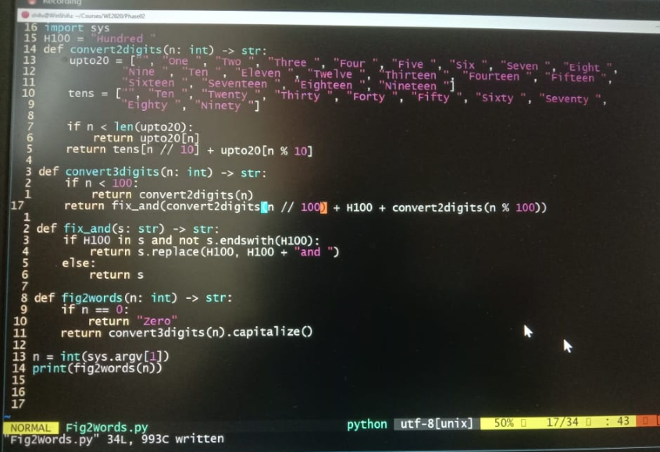

CODE –

under_20 = ['Zero', 'One', 'Two', 'Three', 'Four', 'Five', 'Six', 'Seven', 'Eight', 'Nine', 'Ten','Eleven', 'Twelve', 'Thirteen', 'Fourteen', 'Fifteen', 'Sixteen', 'Seventeen', 'Eighteen', 'Nineteen']

tens = ['Twenty', 'Thirty', 'Forty', 'Fifty', 'Sixty', 'Seventy', 'Eighty', 'Ninety']

def fig2words(n: int) -> str:

num=n

if num<20:

return under_20[num]

if num < 100:

return tens[(int)(num/10-2)] + (''if num % 10 ==0 else ' ' + under_20[num%10])

k=''

k += under_20[(int)(num/100)]+' Hundred'

num = num% 100

if(num==0):

return k

k=k+' and '

if num<20:

return k + under_20[num]

return k+tens[(int)(num/10-2)] + (""if num % 10 == 0 else" "+ under_20[num%10])